**Task on vpc-01**

**1) Create VPC with 2 private and 2 public subnets.**

Create a VPC

- Open the AWS Management Console and navigate to the VPC Dashboard.

- Click on Create VPC.

- Provide a name for the VPC.

- Set the IPv4 CIDR block (e.g., 10.0.0.0/16).

- Enable DNS hostname if required.

- Click Create VPC.

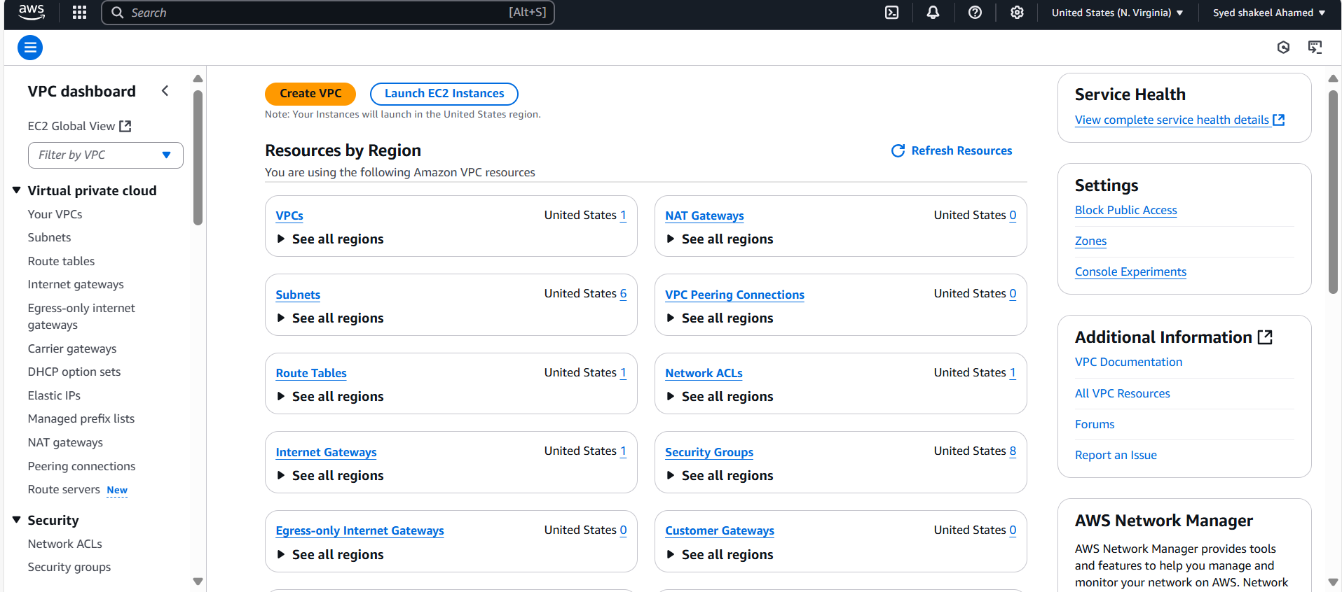

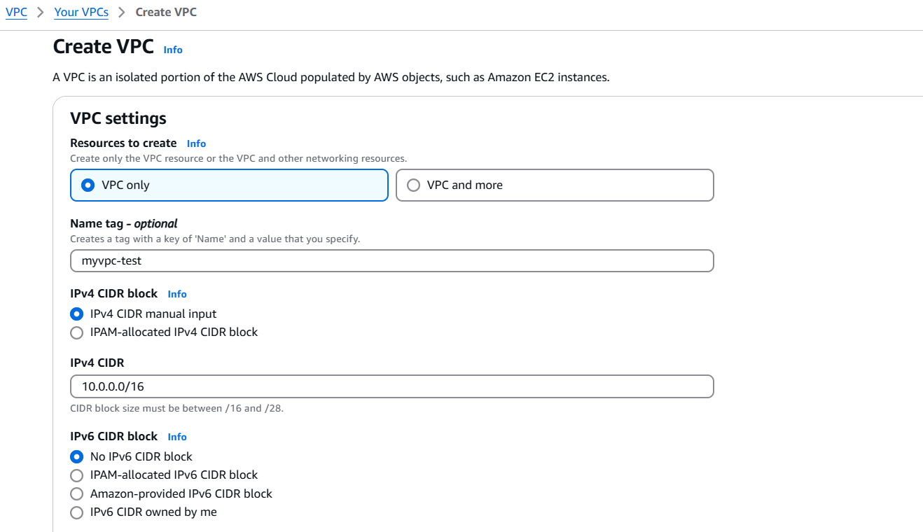

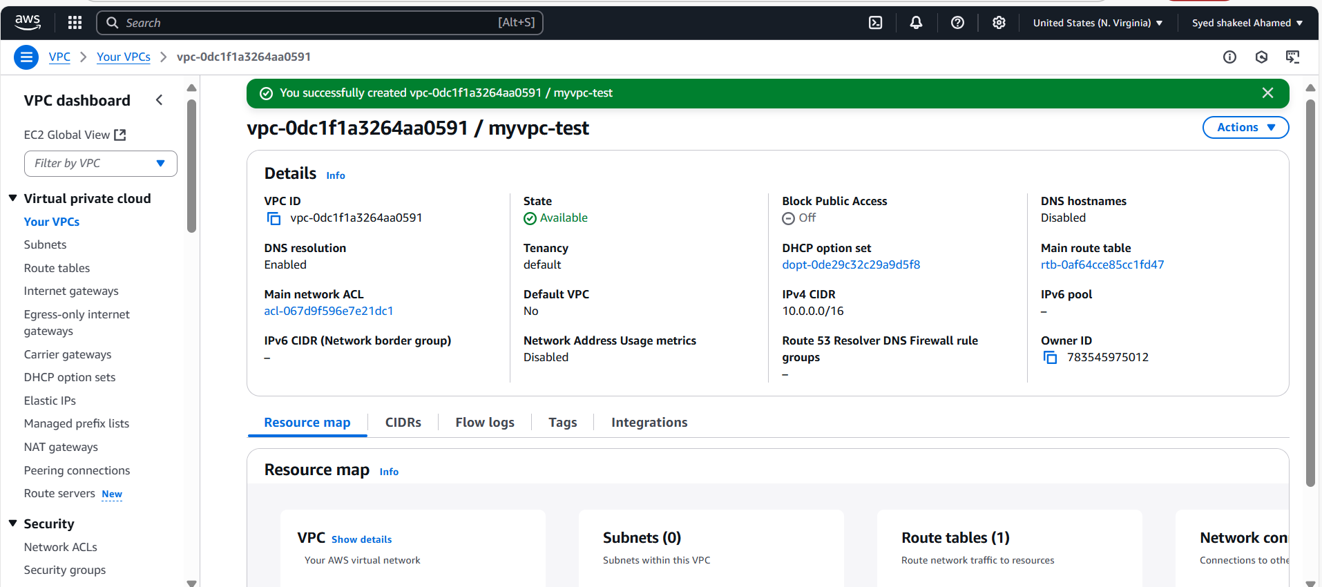

**Create Subnets**

**Public Subnets**

**- Go to the Subnets section in the VPC console.**

**- Click Create Subnet.**

**- Select the newly created VPC.**

**- Assign a name (e.g., Public-Subnet-1).**

**- Set the CIDR block (e.g., 10.0.1.0/24).**

**- Choose an Availability Zone.**

**- Enable Auto-assign Public IP.**

**- Click Create Subnet.**

**- Repeat these steps to create a second public subnet (10.0.2.0/24).**

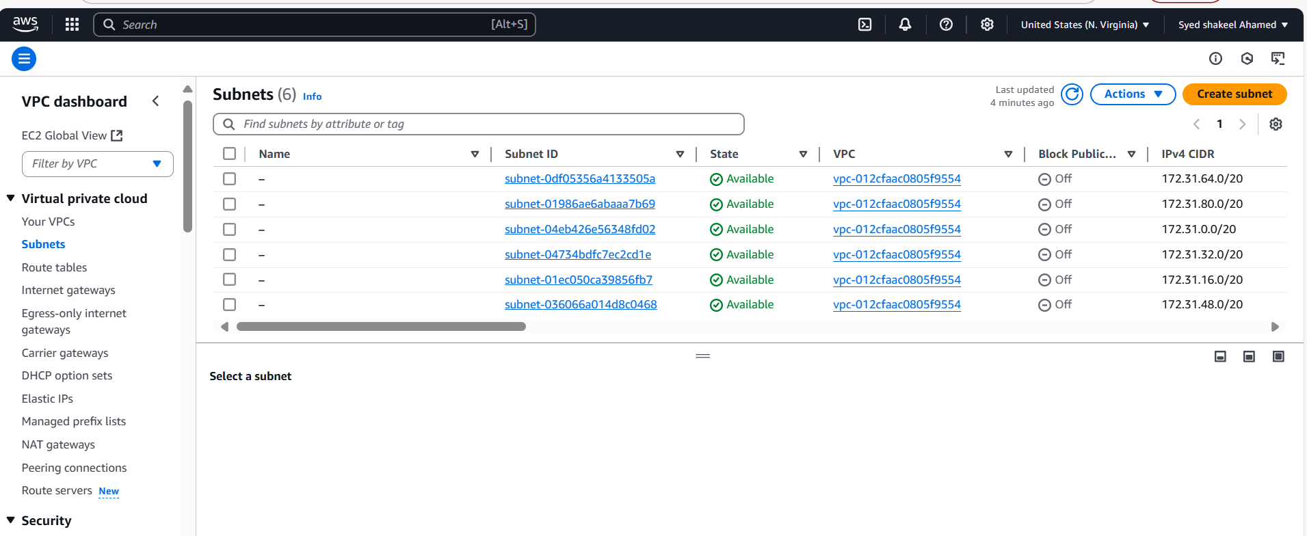

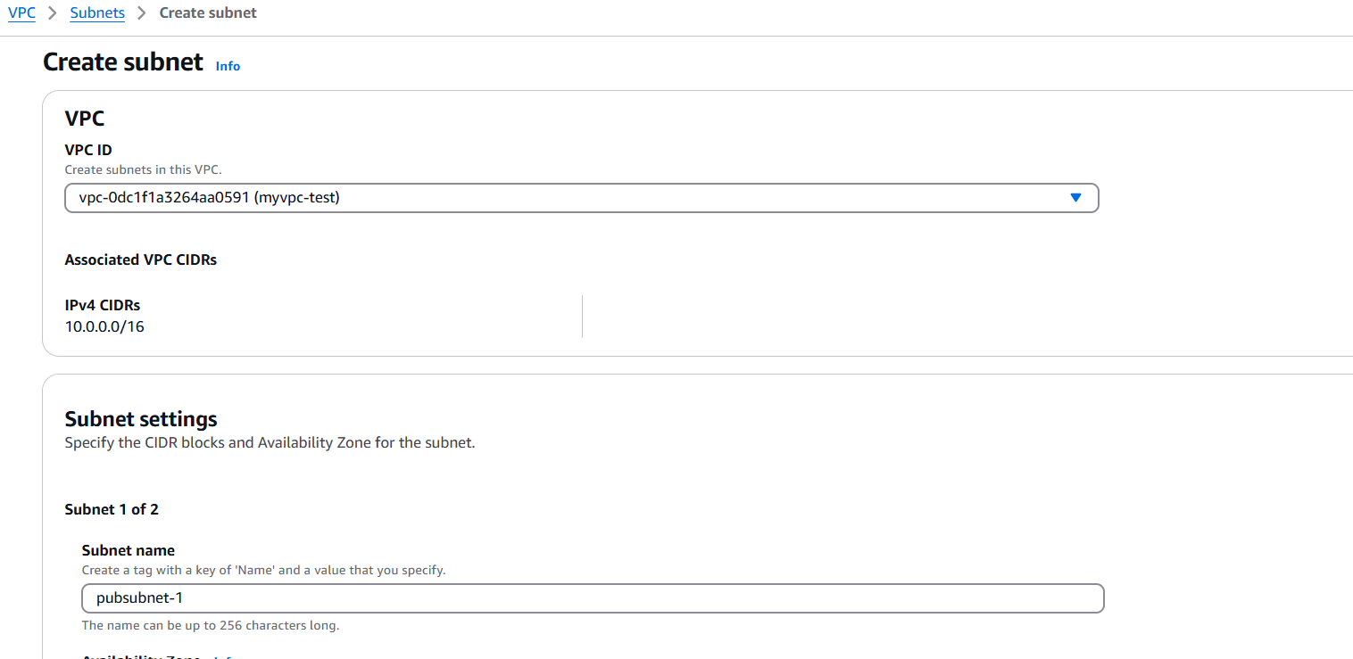

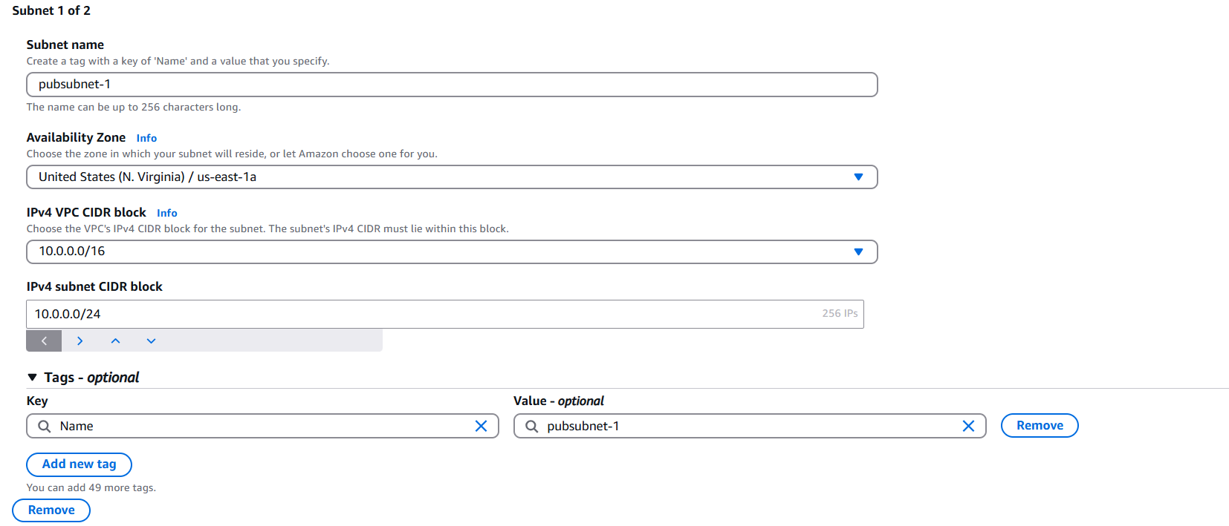

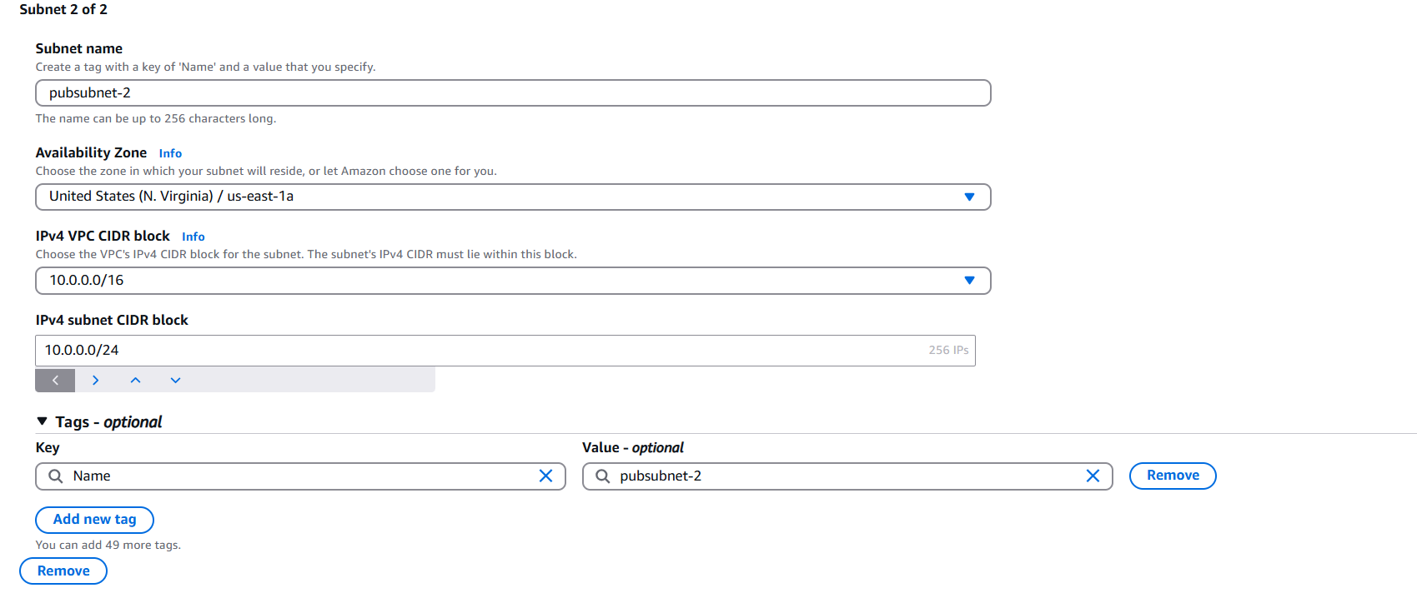

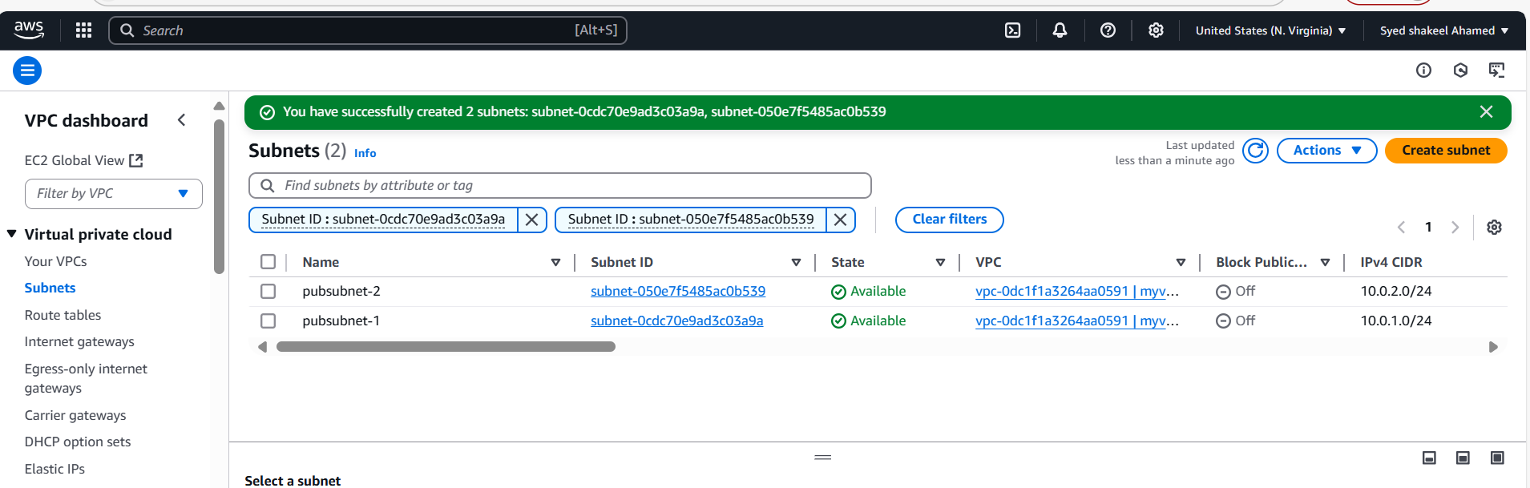

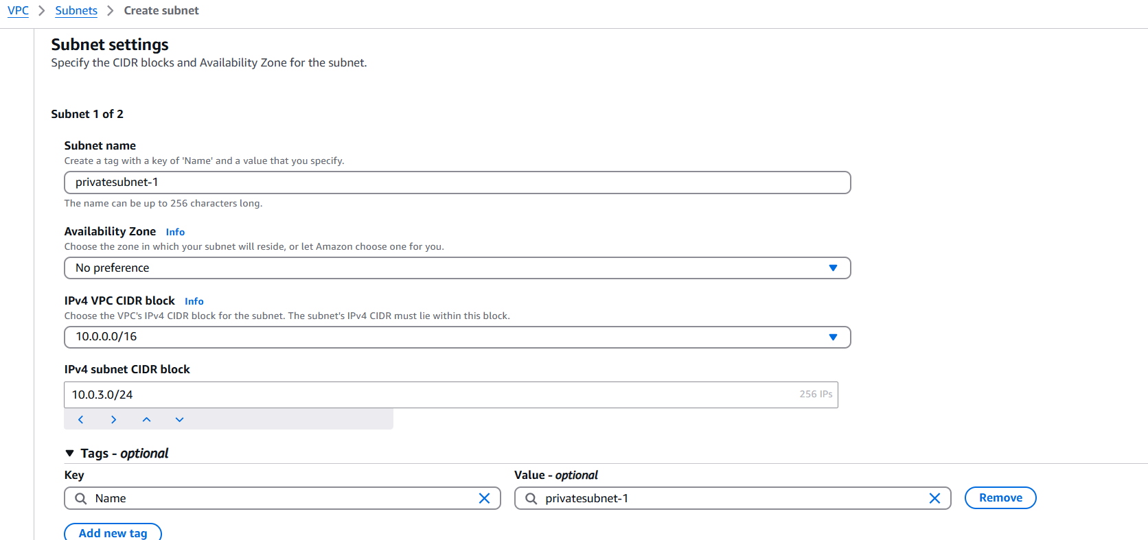

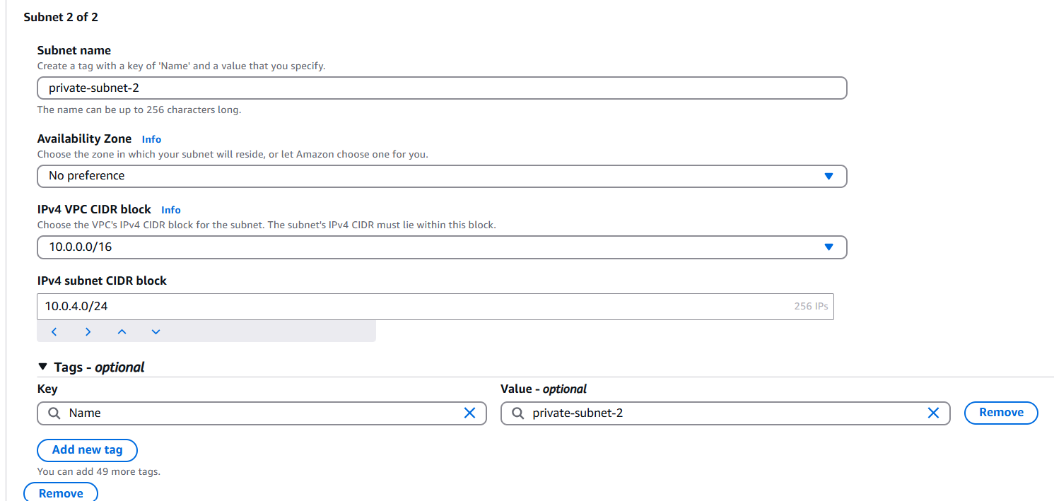

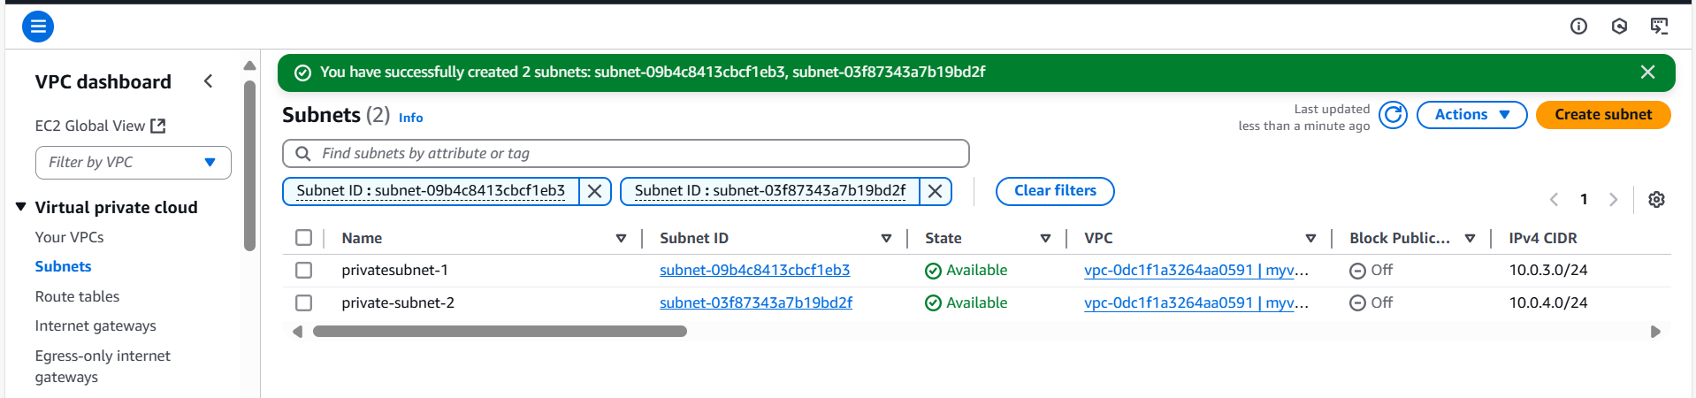

Create an Internet Gateway

- Navigate to Internet Gateways.

- Click Create Internet Gateway.

- Provide a name (e.g., MyIGW).

- Click Create and then Attach to VPC.

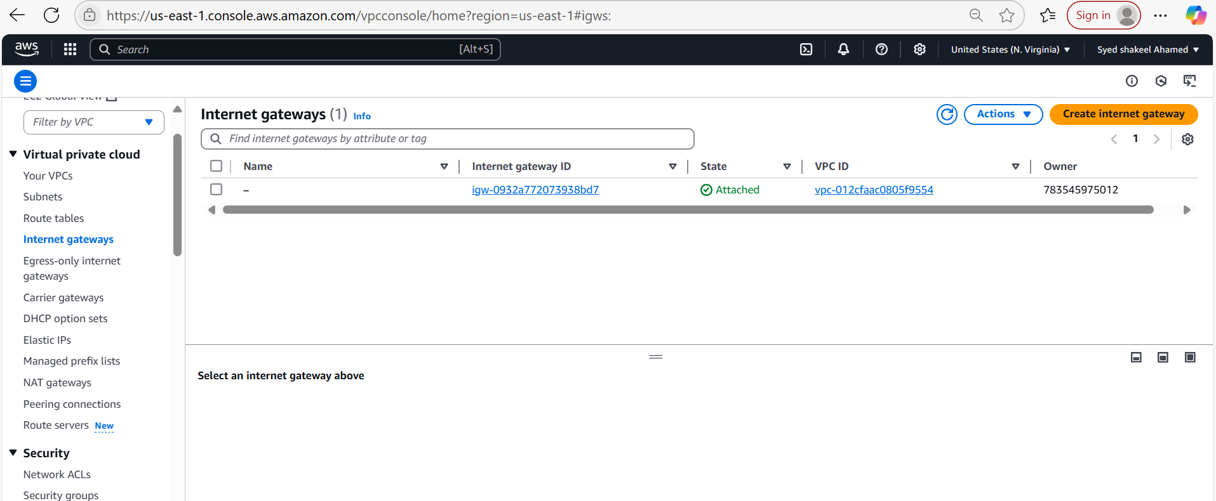

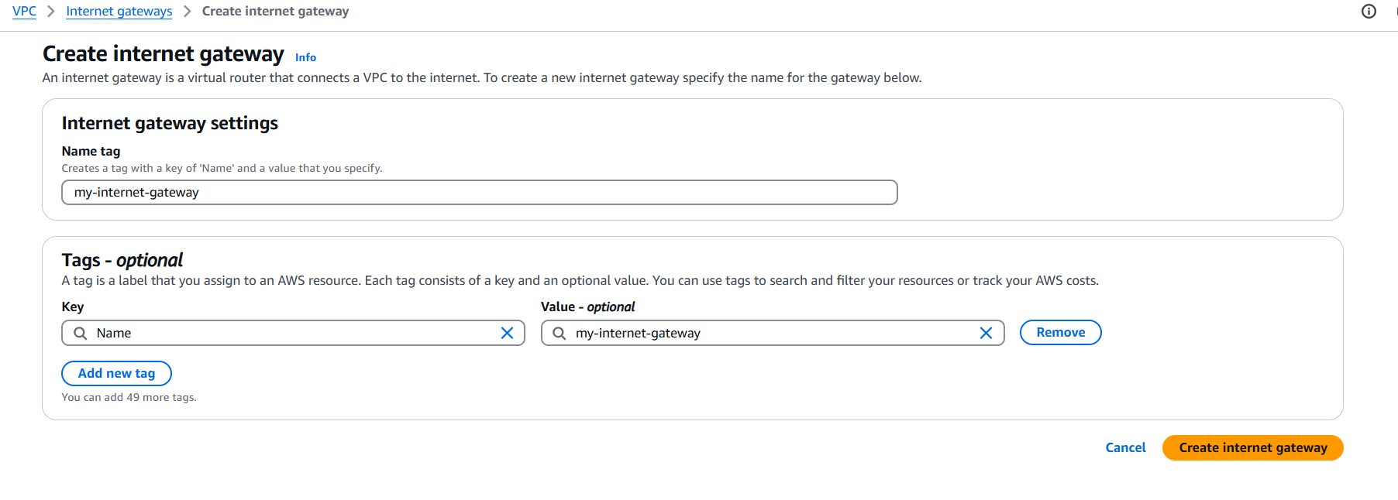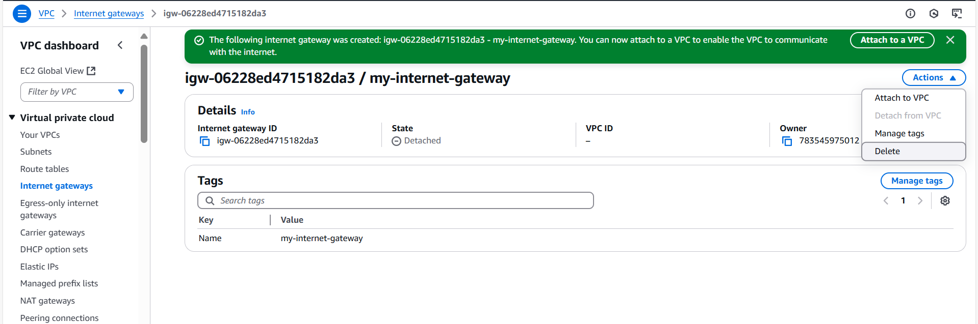

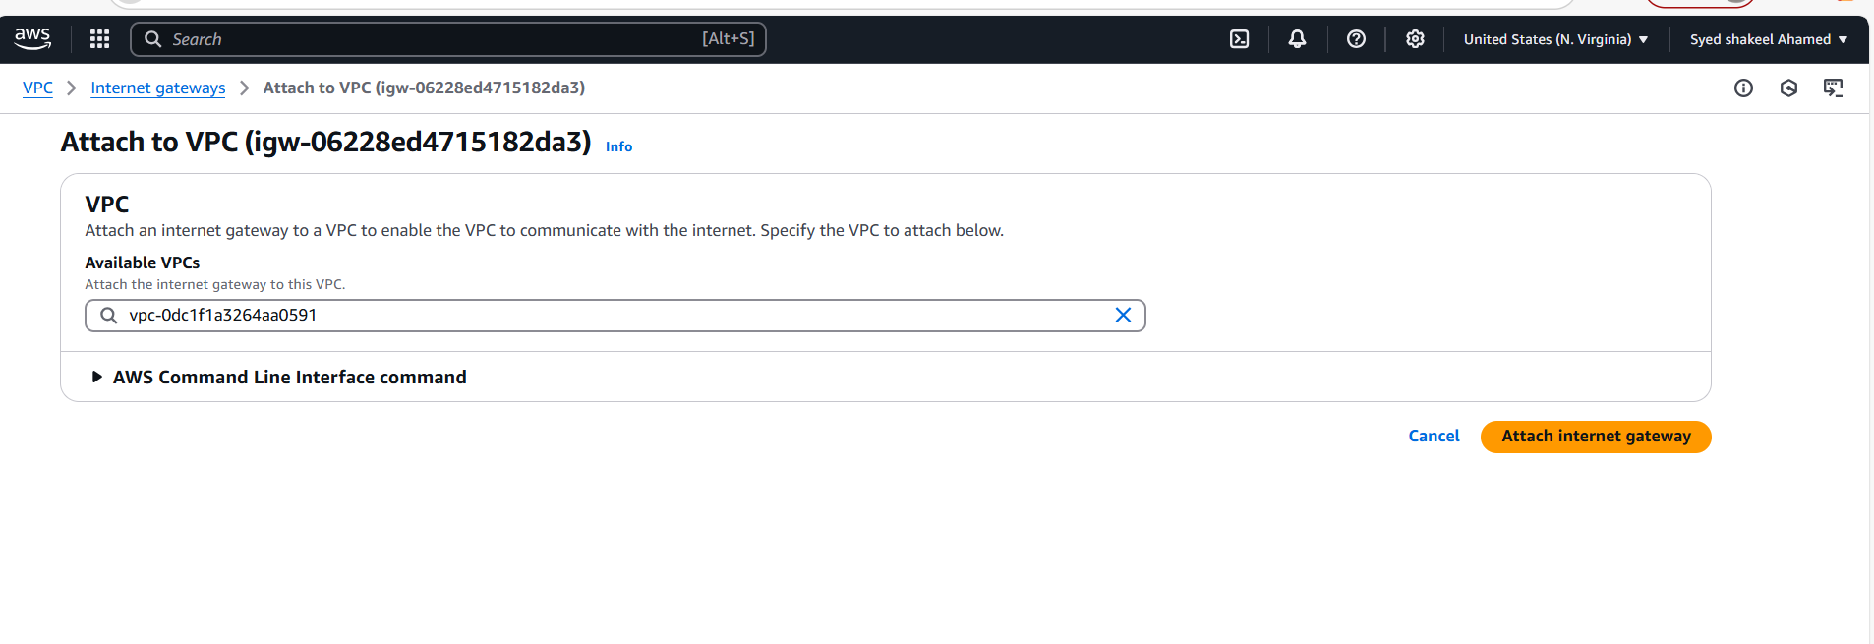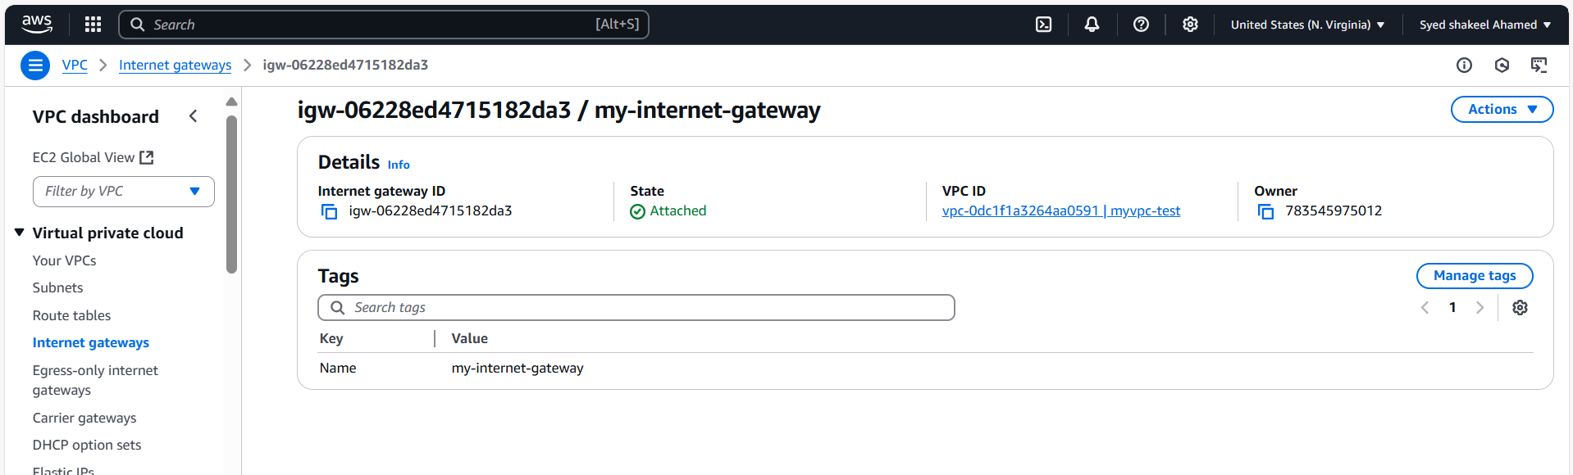

Configure Route Tables

- Go to Route Tables.

- Select the Main Route Table and associate it with private subnets.

- Click Edit Routes, add a route for local traffic, and save.

- Click Create Route Table for public subnets.

- Add a route (0.0.0.0/0) pointing to the Internet Gateway.

- Associate the route table with public subnets.

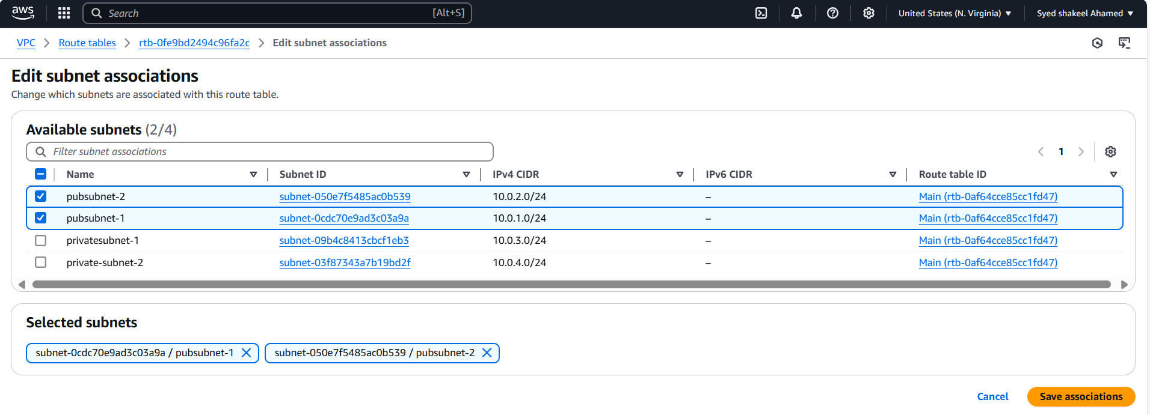

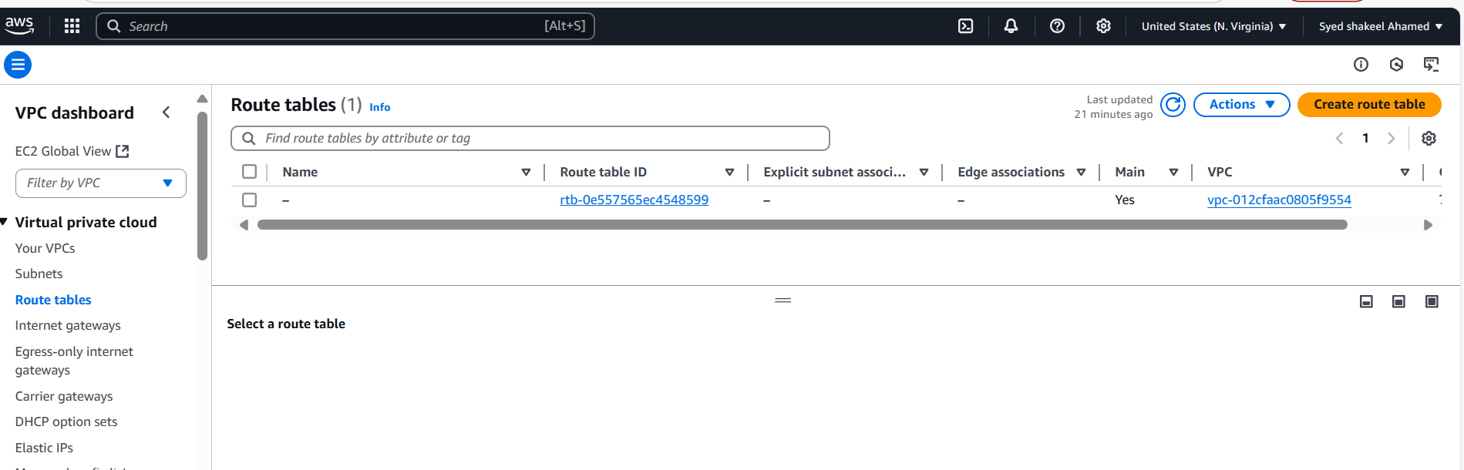

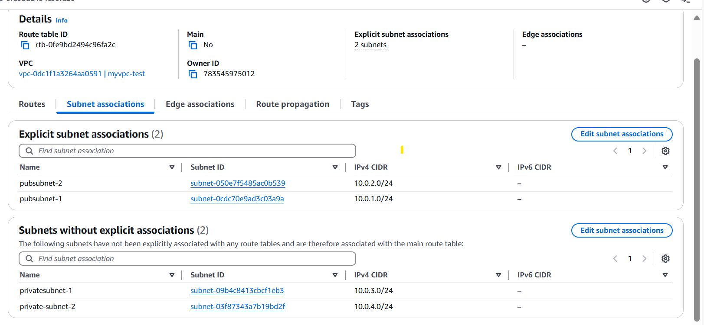

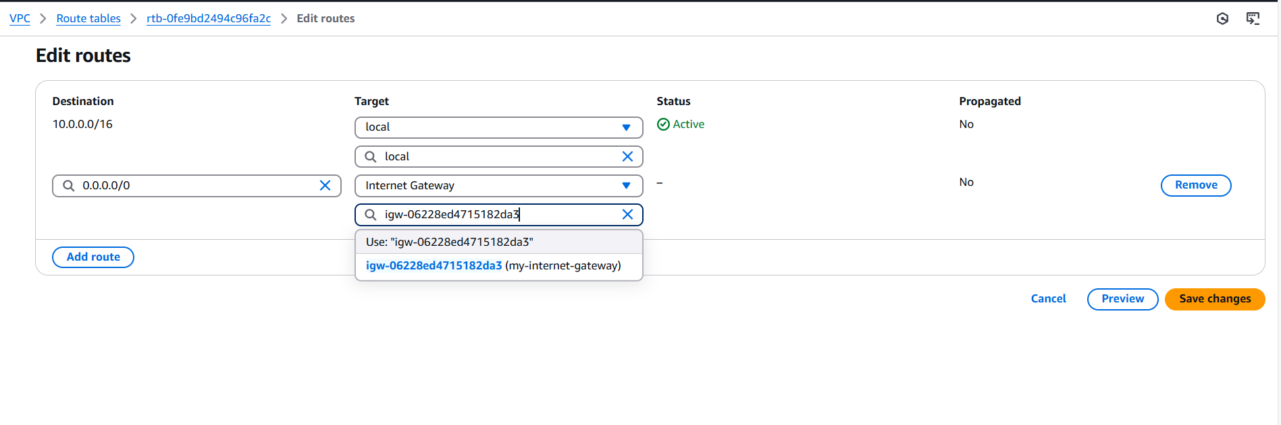

Verify Configuration

- Test by launching an EC2 instance in both public and private subnets.

- Verify connectivity using ping or curl from public to private instances.

- Check whether private instances access the internet via the NAT Gateway.

This setup ensures a secure, scalable VPC with isolated private subnets and internet-accessible public subnets.

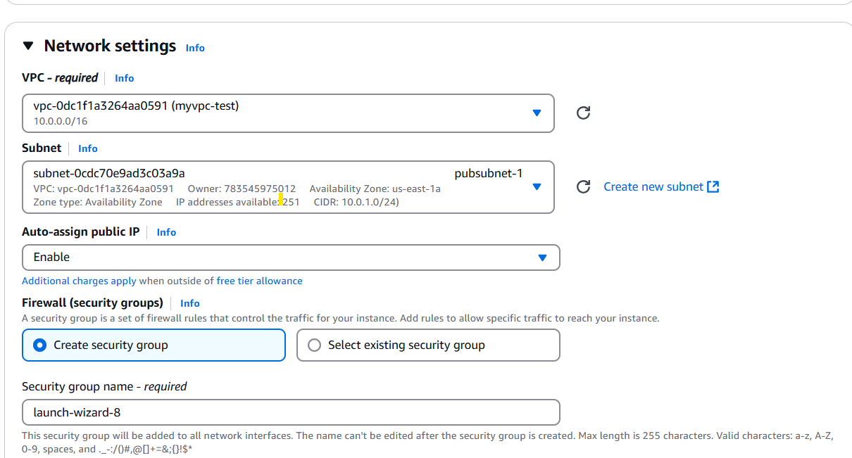

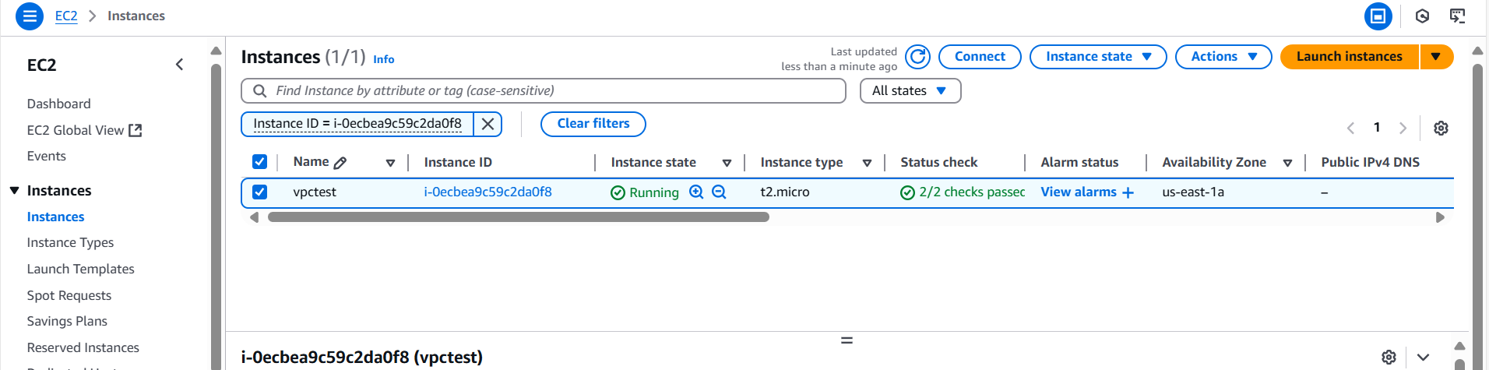

Ping google.com using pubsubnet-1

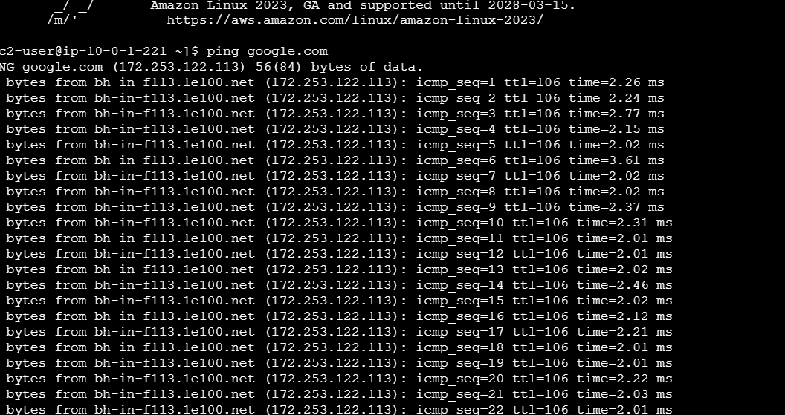

Ping google.com using private ipv4

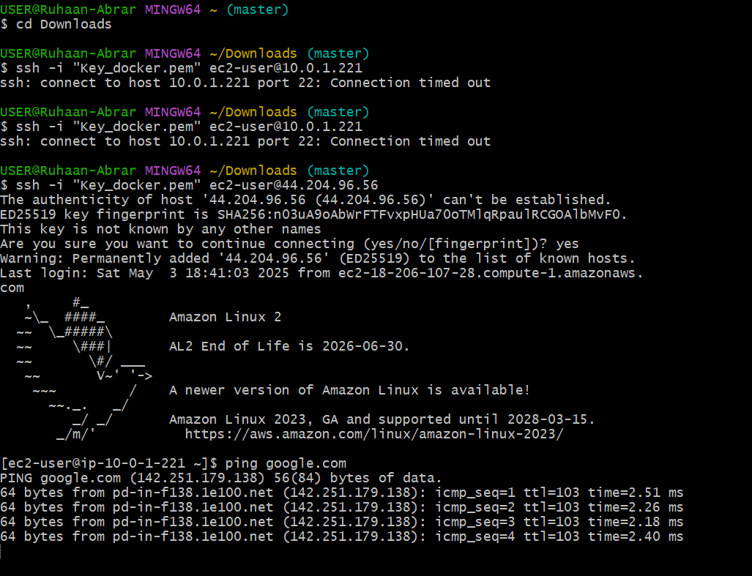

**2) Enable DNS Hostname in VPC**

**Select the VPC**

**- Identify the VPC where you want to enable DNS hostnames.**

**- Click on the VPC ID to open its details.**

**Modify DNS Settings**

**- In the VPC details section, locate the DNS attributes.**

**- Click Edit DNS hostnames.**

**- Toggle Enable DNS hostnames to ON.**

**- Click Save changes.**

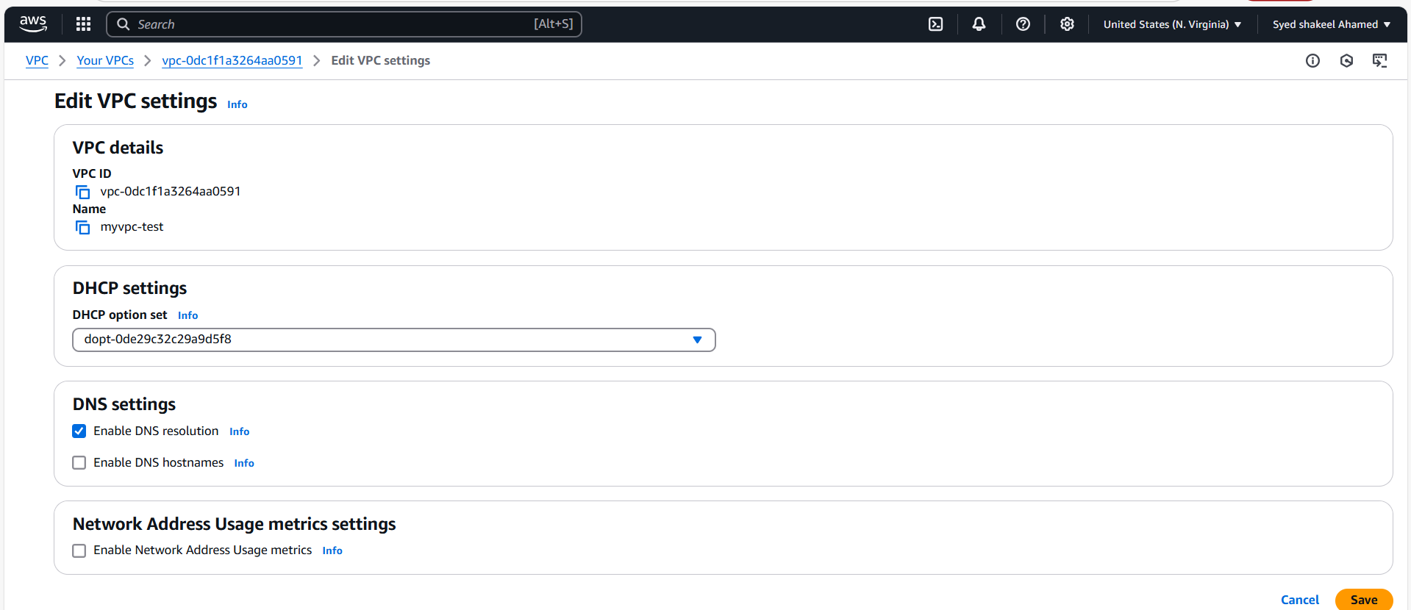

Verify Configuration

- Navigate to the EC2 Dashboard.

- Select an instance running inside the VPC.

- Check the Public DNS in the instance details—it should now display a hostname like:

ec2-44-204-96-56.compute-1.amazonaws.com

- Open a terminal and test connectivity using:

ping ec2-XX-XX-XX-XX.compute-1.amazonaws.com

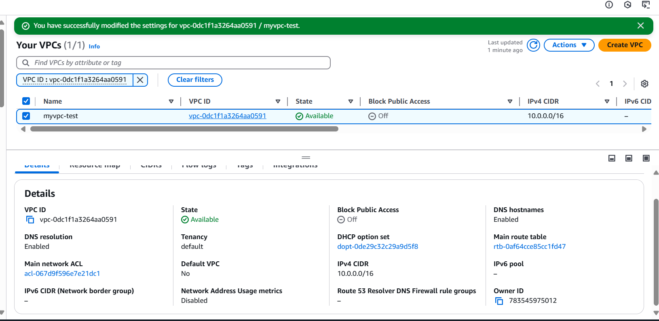

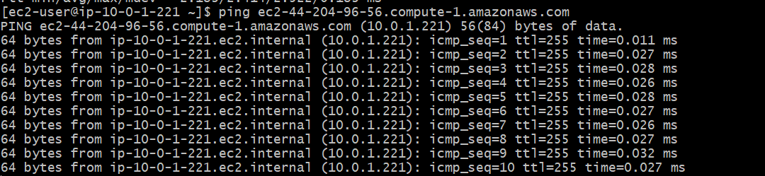

**3) Enable Auto Assign Public ip in 2 public subnets**

**Select the Public Subnets**

**- Identify the two public subnets where you want to enable Auto-Assign Public IP.**

**- Click on the Subnet ID of the first subnet to open its details.**

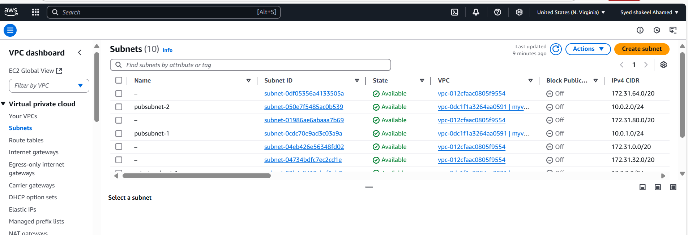

**Enable Auto-Assign Public IP**

**- In the Subnet details section, locate Auto-assign public IPv4 address.**

**- Click Edit.**

**- Select Enable Auto-Assign Public IP.**

**- Click Save changes.**

**- Repeat these steps for the second public subnet.**

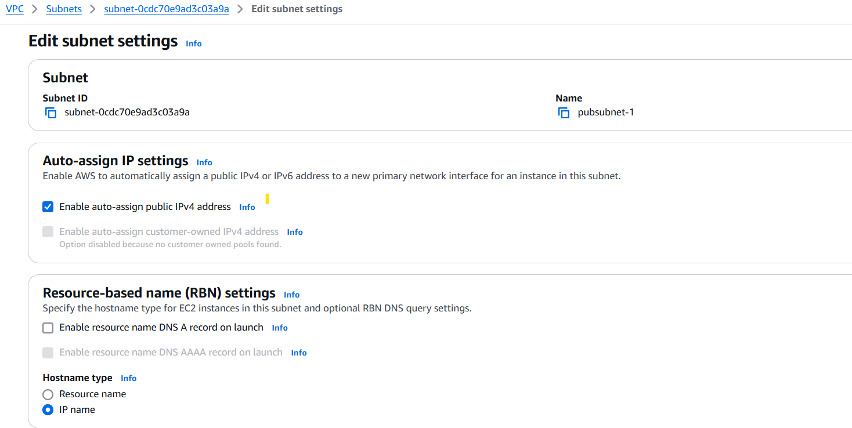

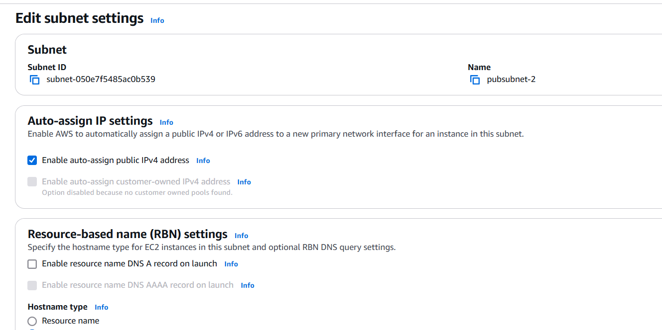

Verify Configuration

- Launch an EC2 instance in the public subnet.

- In the EC2 instance details, check if a Public IPv4 address is assigned automatically.

- If assigned, test connectivity using:

ping 34.205.41.50

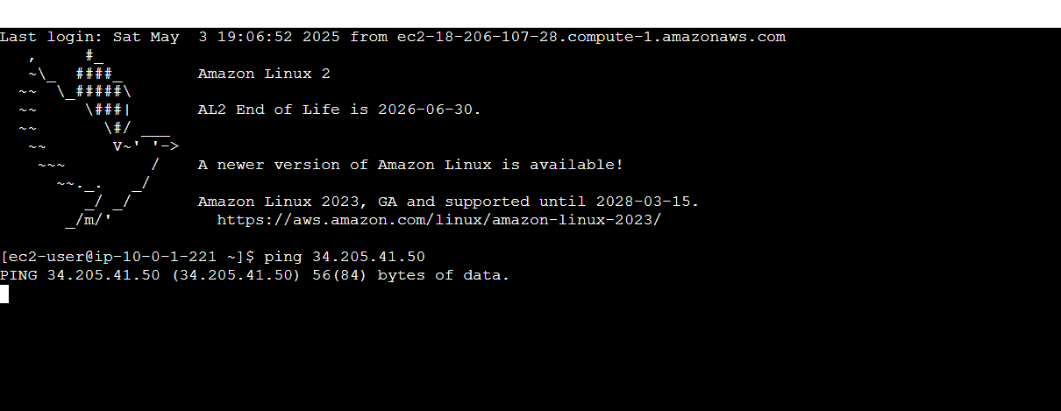

**4) Add 2 private subnets in private route table**

**Identify the Private Route Table**

**- Look for the route table associated with private subnets (typically labeled as Private Route Table).**

**- If you don’t have a private route table:**

**- Click Create Route Table.**

**- Select the VPC and provide a name (e.g., Private-Route-Table).**

**- Click Create Route Table.**

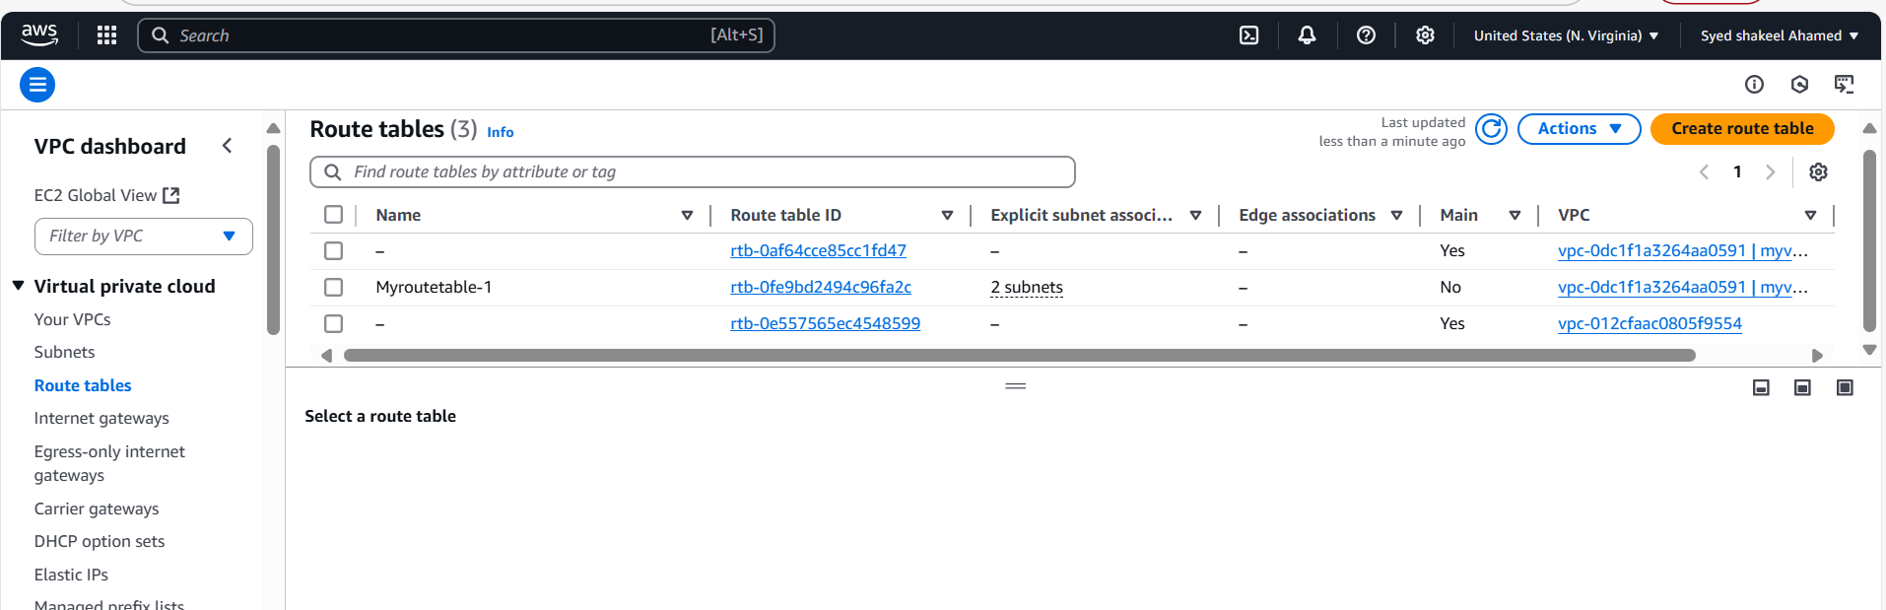

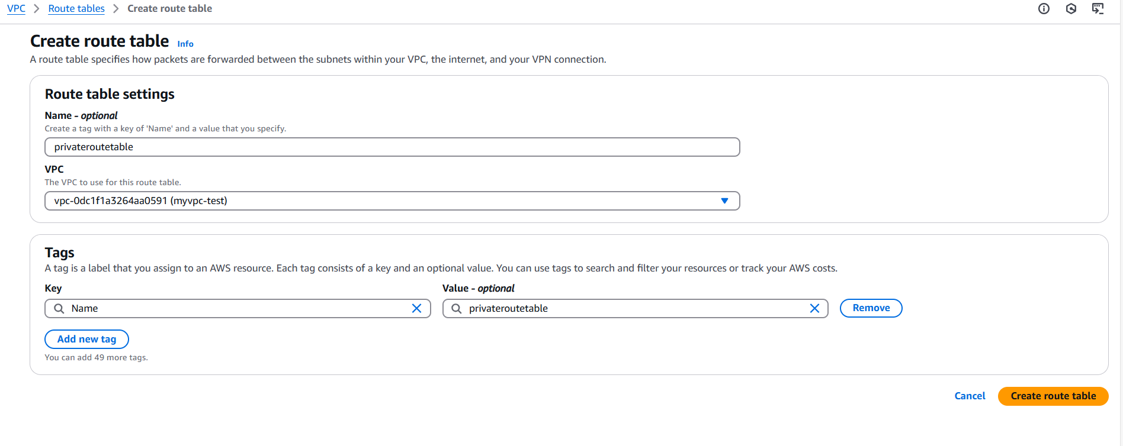

**Associate Private Subnets with the Route Table**

**- In the Route Tables section, select the private route table.**

**- Click the Subnet Associations tab.**

**- Click Edit Subnet Associations.**

**- Select the two private subnets you want to add.**

**- Click Save Associations.**

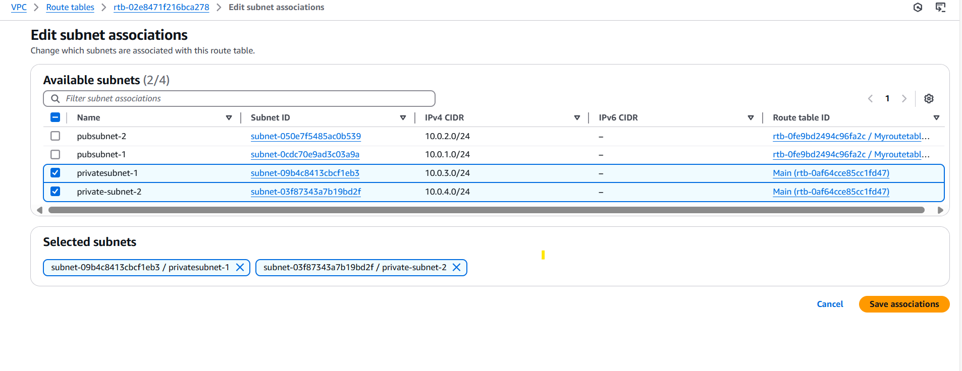

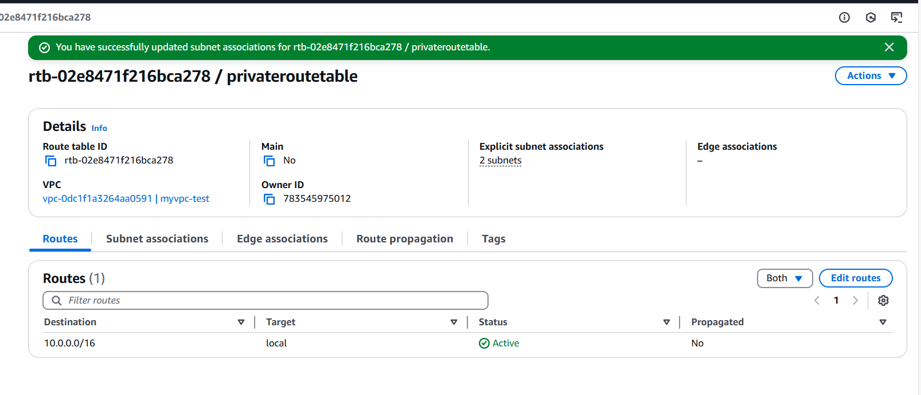

**5) Add 2 public subnets in public route table**

dentify the Public Route Table

- Look for the route table associated with public subnets (typically labeled Public Route Table).

- If you don’t have a public route table:

- Click Create Route Table.

- Select the VPC and provide a name (e.g., Public-Route-Table).

- Click Create Route Table.

Associate Public Subnets with the Route Table

- In the Route Tables section, select the public route table.

- Click the Subnet Associations tab.

- Click Edit Subnet Associations.

- Select the two public subnets you want to add.

- Click Save Associations.

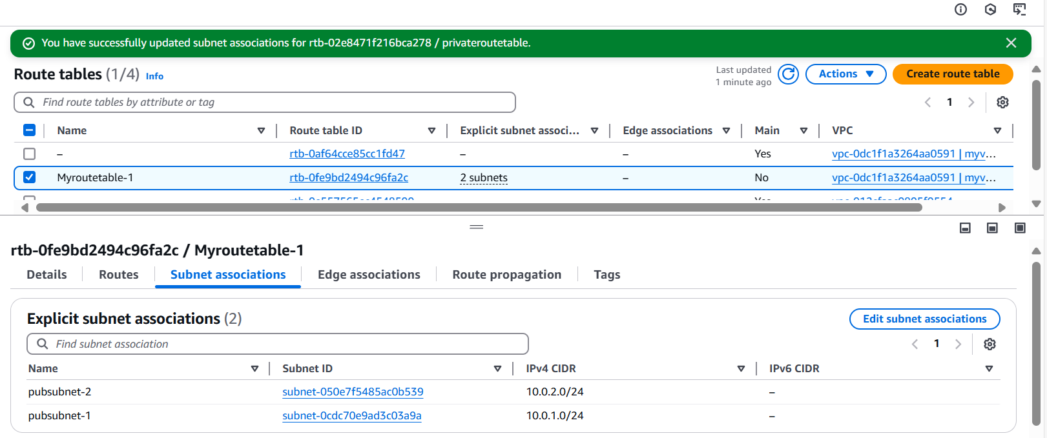

**6) Public route table will have the routes to internet and local**

**Add Routes to the Public Route Table**

**- Open the Routes tab in the route table.**

**- Click Edit Routes.**

**- Add a route for local traffic within the VPC:**

**Destination: 10.0.0.0/16 (VPC CIDR)**

**Target: local**

**- Add a route for internet-bound traffic through an Internet Gateway (IGW):**

**Destination: 0.0.0.0/0**

**Target: <Internet Gateway ID>**

**- Click Save Changes.**

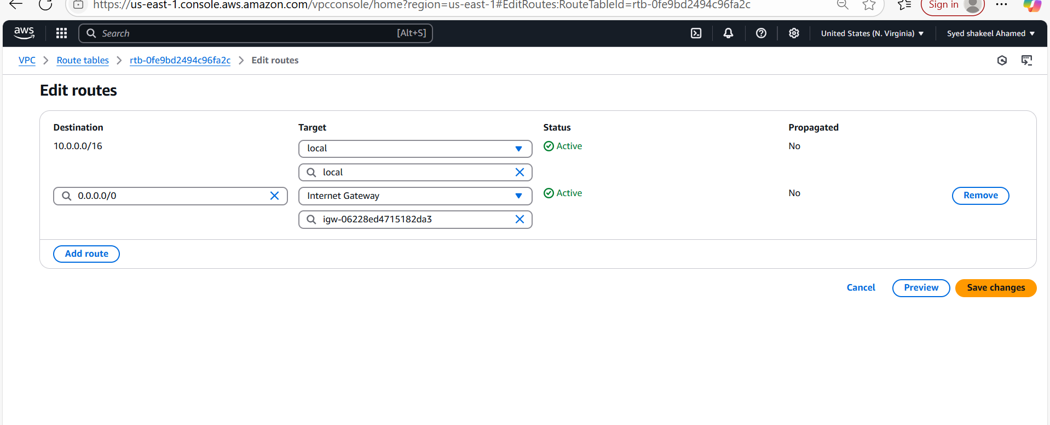

Verify Route Table Configuration

- Launch an EC2 instance in one of the public subnets.

- Ensure the instance has Auto-Assign Public IP enabled.

- Test connectivity to the internet using:

ping google.com

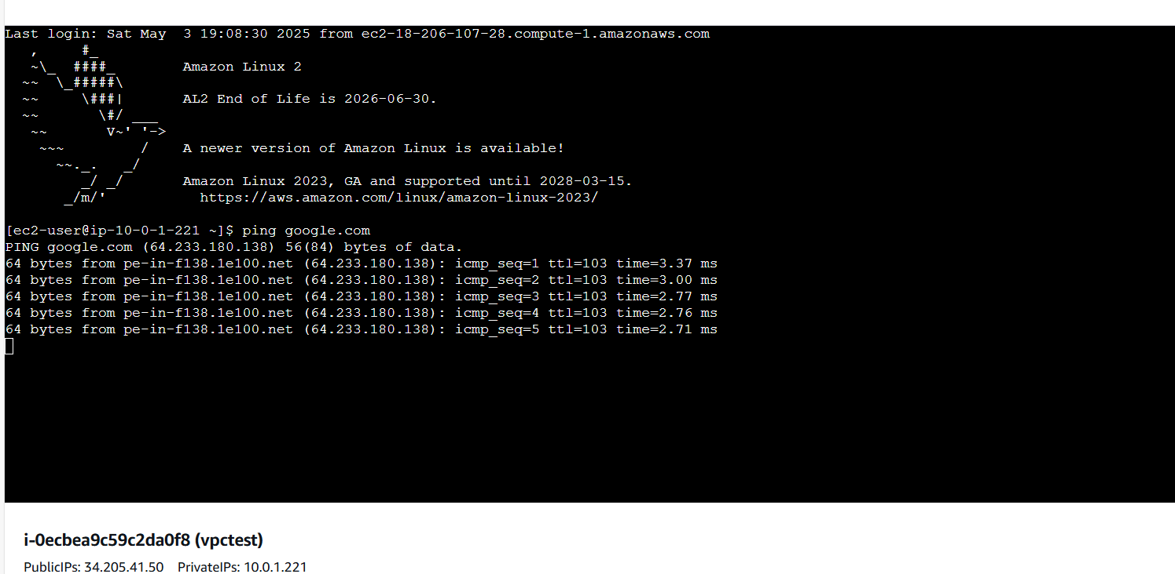

**7) Create Ec2 in public subnet with t2micro and install php**

**Launch EC2 Instance which I have installed vpctest**

**- Click Launch.**

**- Select or create a key pair to access the instance.**

**- Click Launch Instance.**

**- Wait for the instance to start, then go to EC2 Dashboard → Instances.**

**- Copy the Public IPv4 address.**

**Step 6: Connect to the EC2 Instance**

**- Open a terminal and connect via SSH:**

**ssh -i /path/to/key.pem ec2-user@34.205.41.50**

**Install PHP**

**- Update the package list:**

**sudo yum update -y**

**Install PHP:**

**sudo yum install -y php**

**- Verify installation:**

**php -v**

**Set Up a Basic PHP Server**

**- Install Apache (httpd):**

**sudo yum install -y httpd**

**- Start the Apache service:**

**sudo systemctl start httpd # Amazon Linux**

**- Create a simple PHP page:**

**sudo echo "<?php phpinfo(); ?>" > /var/www/html/index.php**

**- Change ownership:**

**sudo chown apache:apache /var/www/html/index.php**

**- Open a browser and access http://** 34.205.41.50 :80 **o verify PHP is working.**

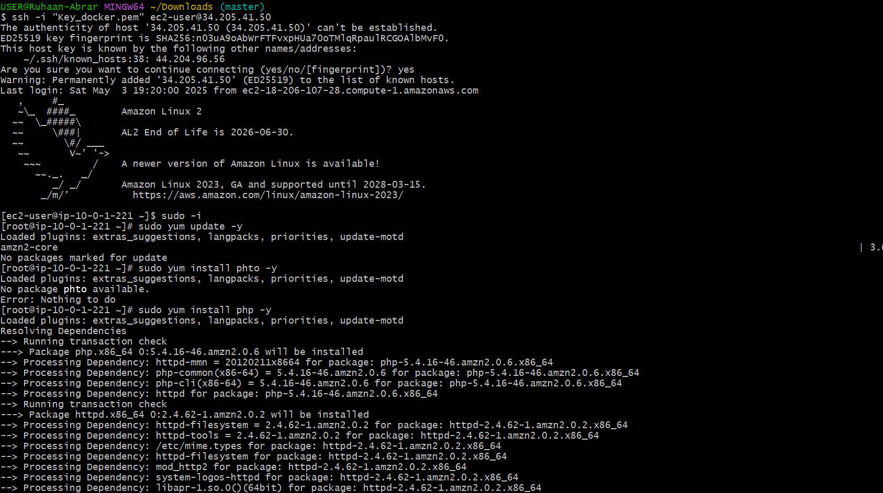

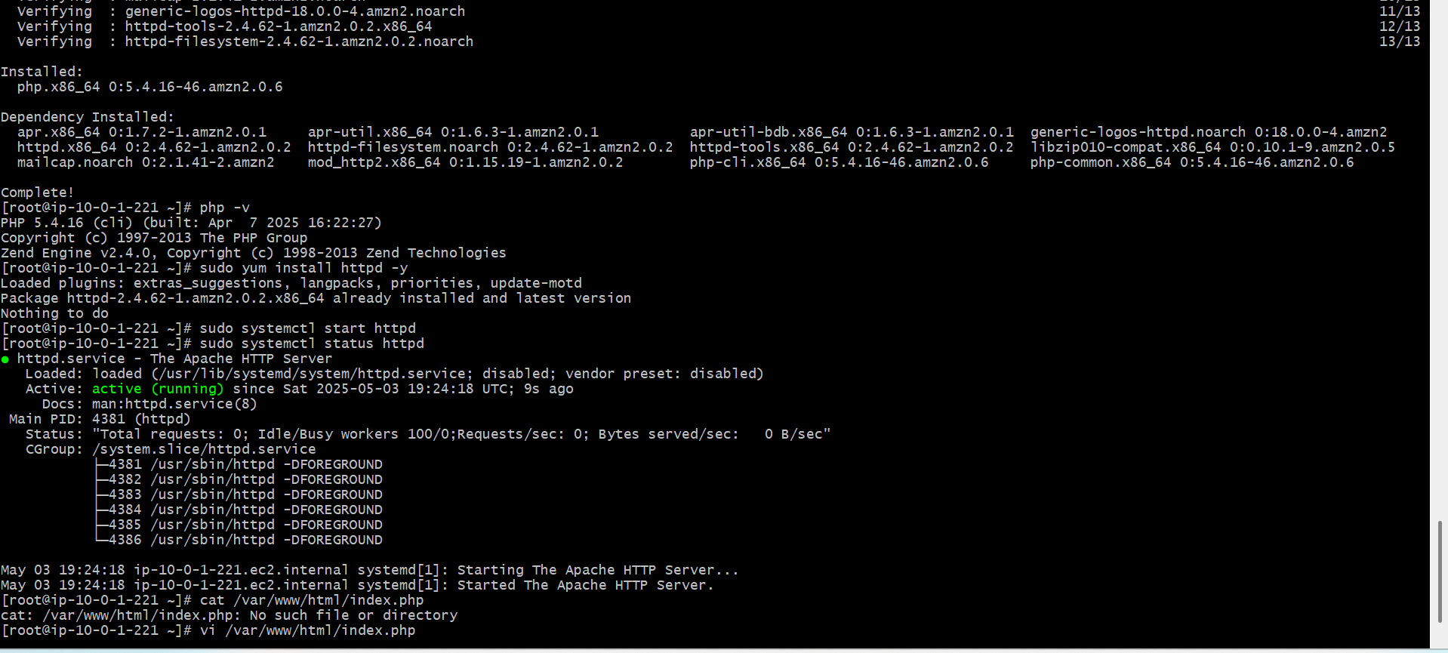

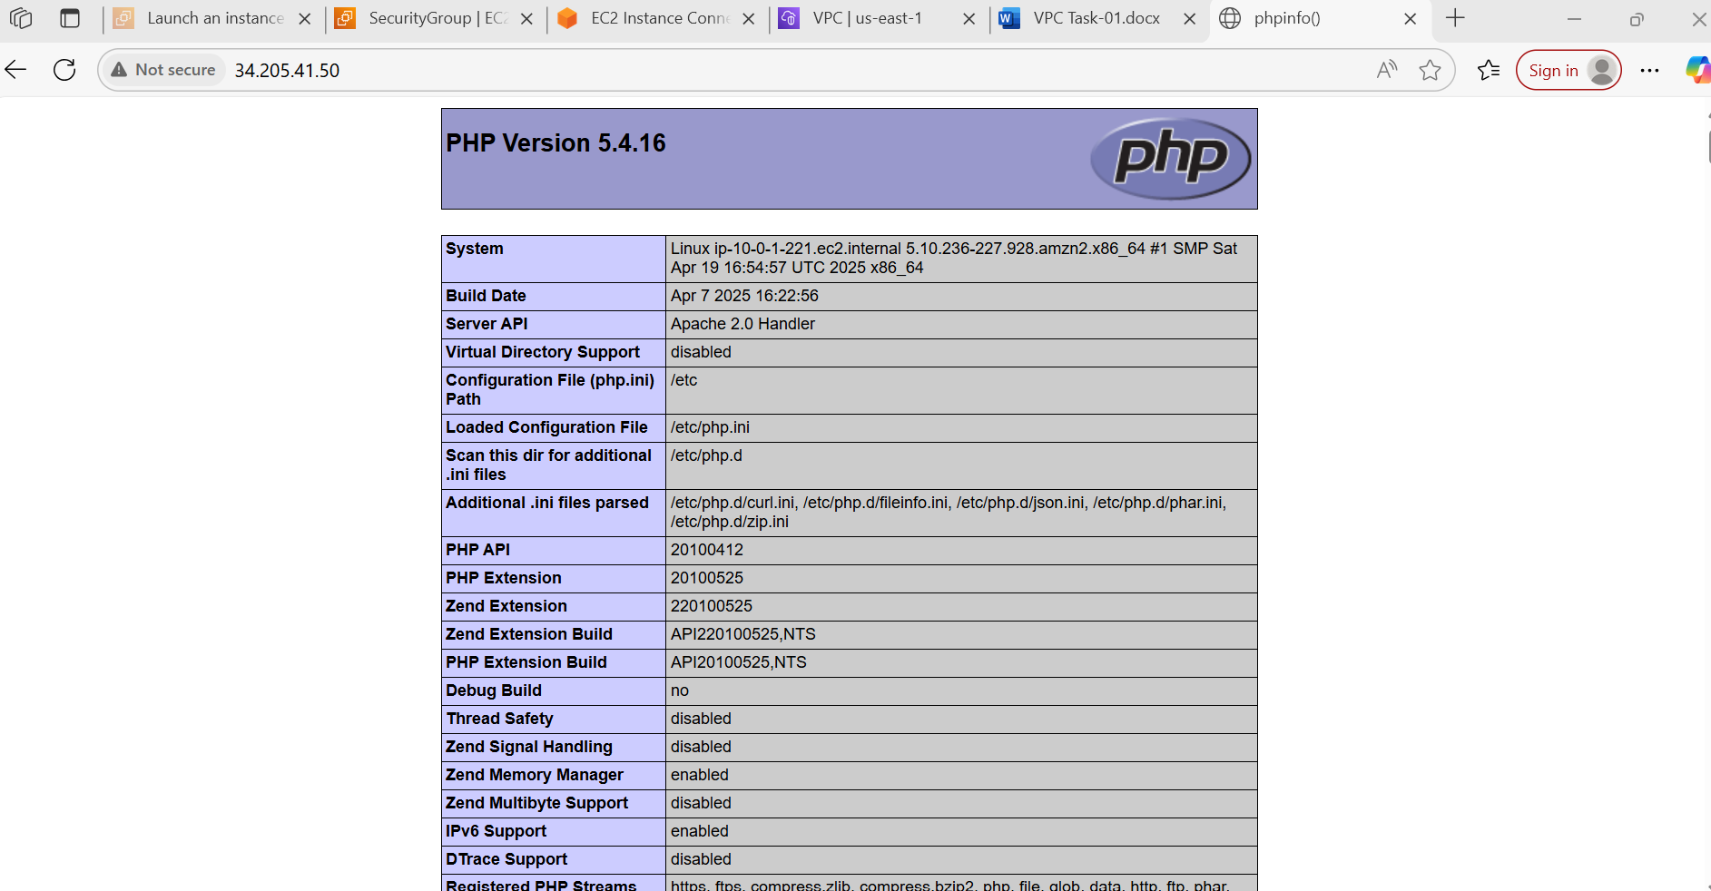

**8) Configure Nat gateway in public subnet and connect to private Instance**

Create a NAT Gateway

- Go to the AWS Console → Navigate to VPC.

- Create an Elastic IP: Go to Elastic IPs and allocate a new one.

- Launch a NAT Gateway:

- Go to NAT Gateways → Click Create NAT Gateway.

- Select the public subnet.

- Attach the Elastic IP.

- Click Create.

Update Route Table for Private Subnet

- Go to Route Tables → Select the private subnet’s route table.

- Edit Routes:

- Add a new route: 0.0.0.0/0 → Target: NAT Gateway.

- Save changes.

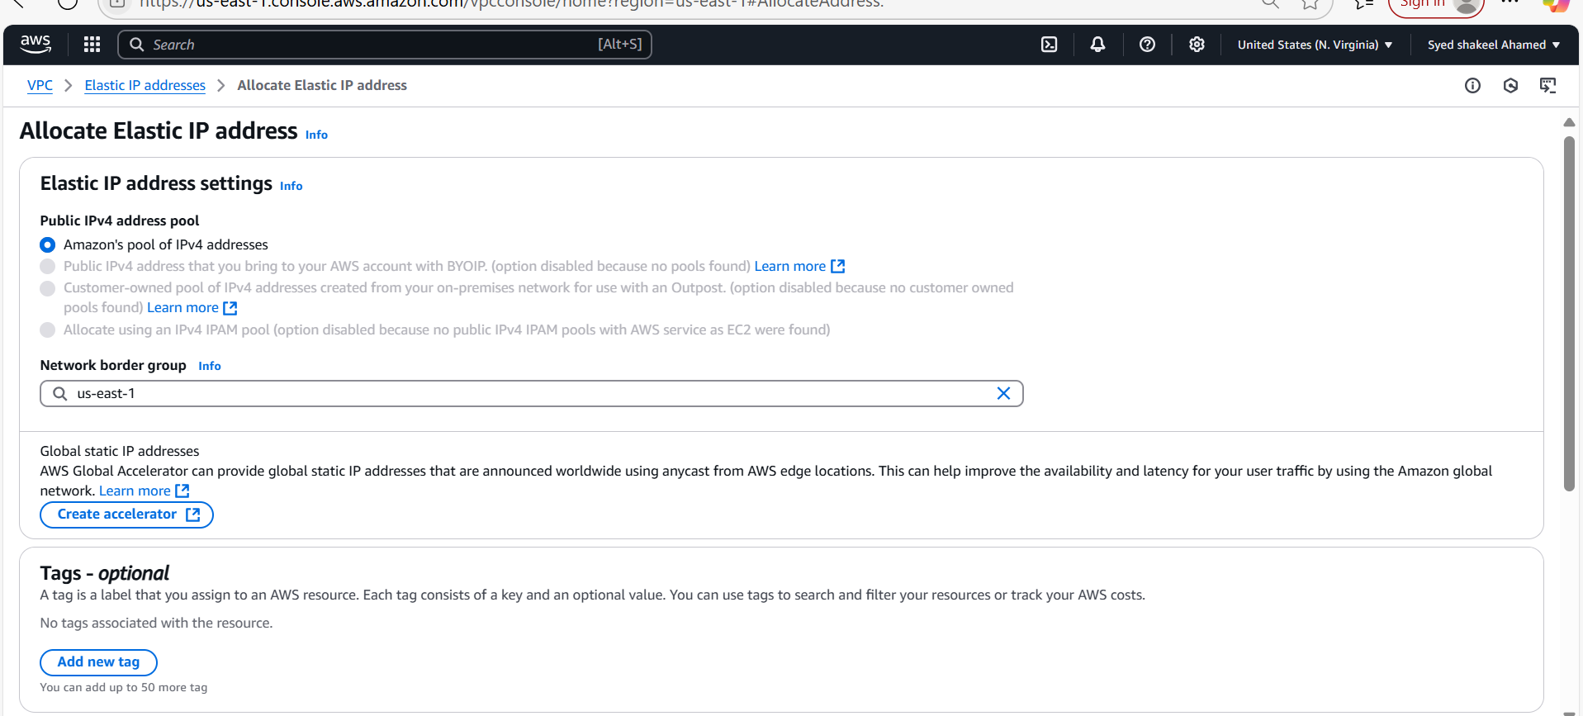

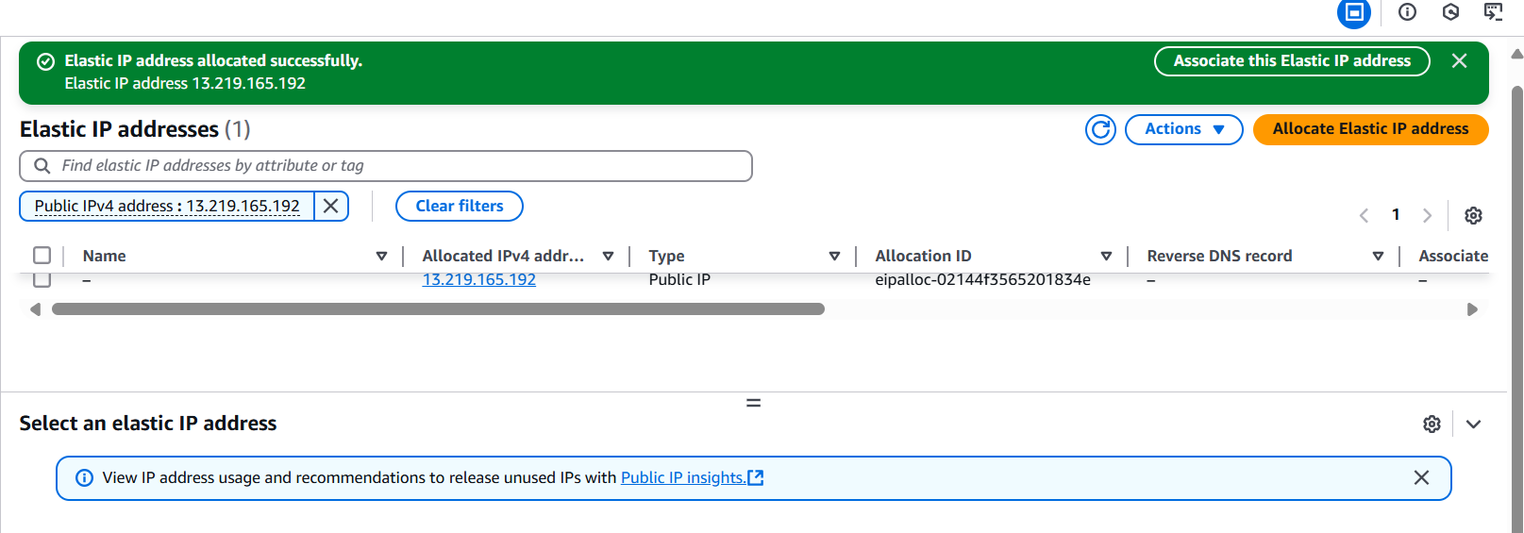

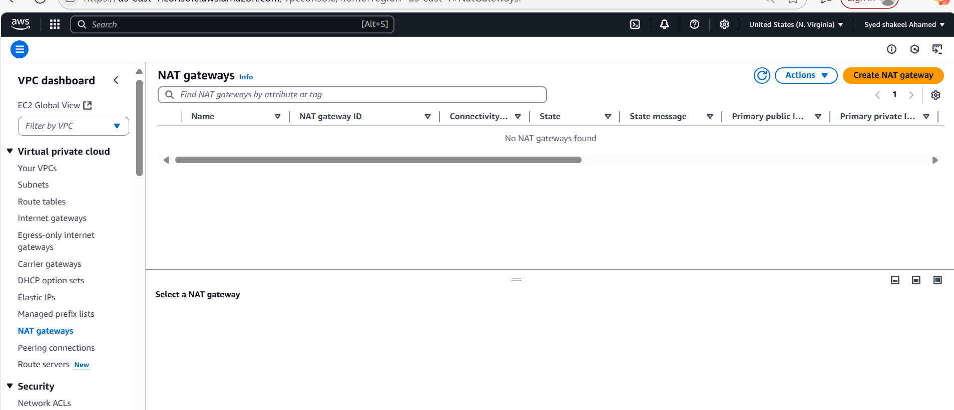

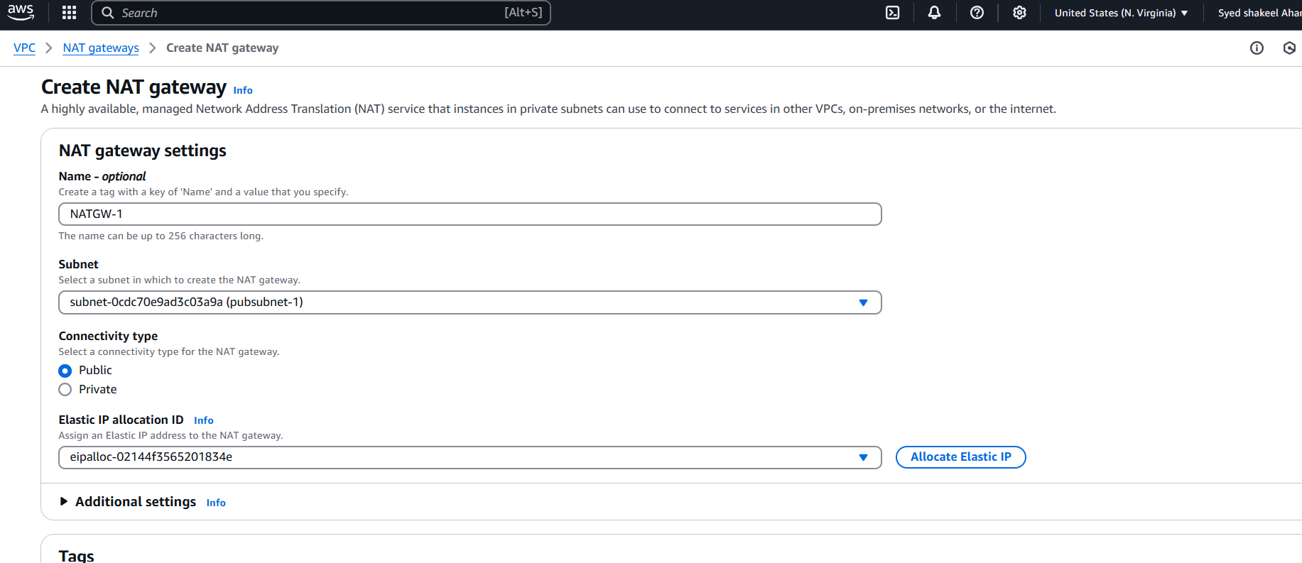

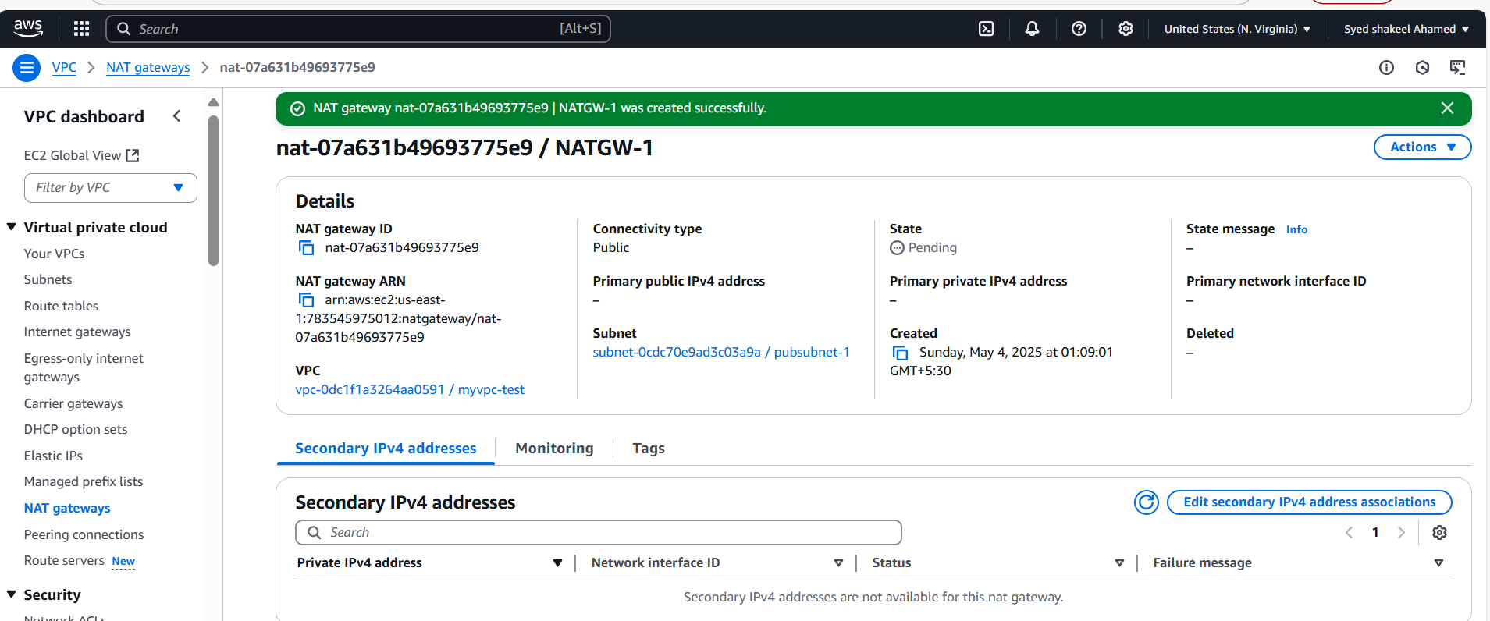

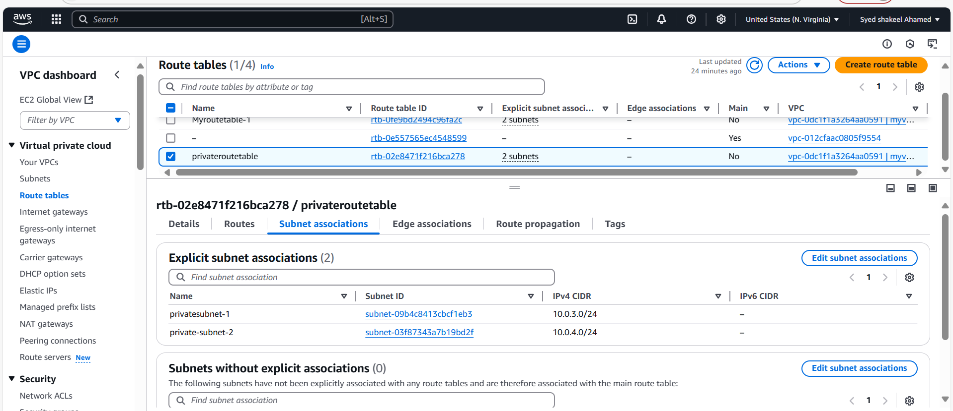

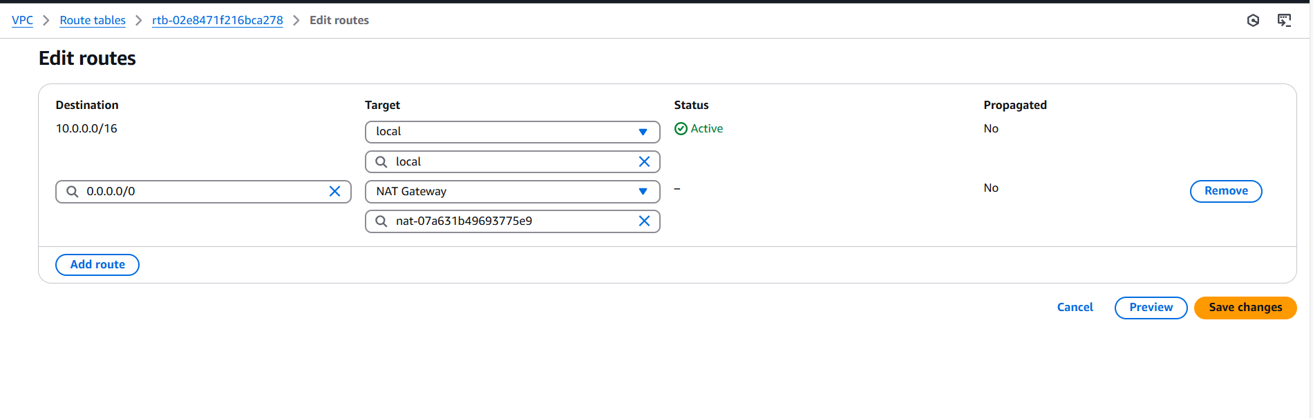

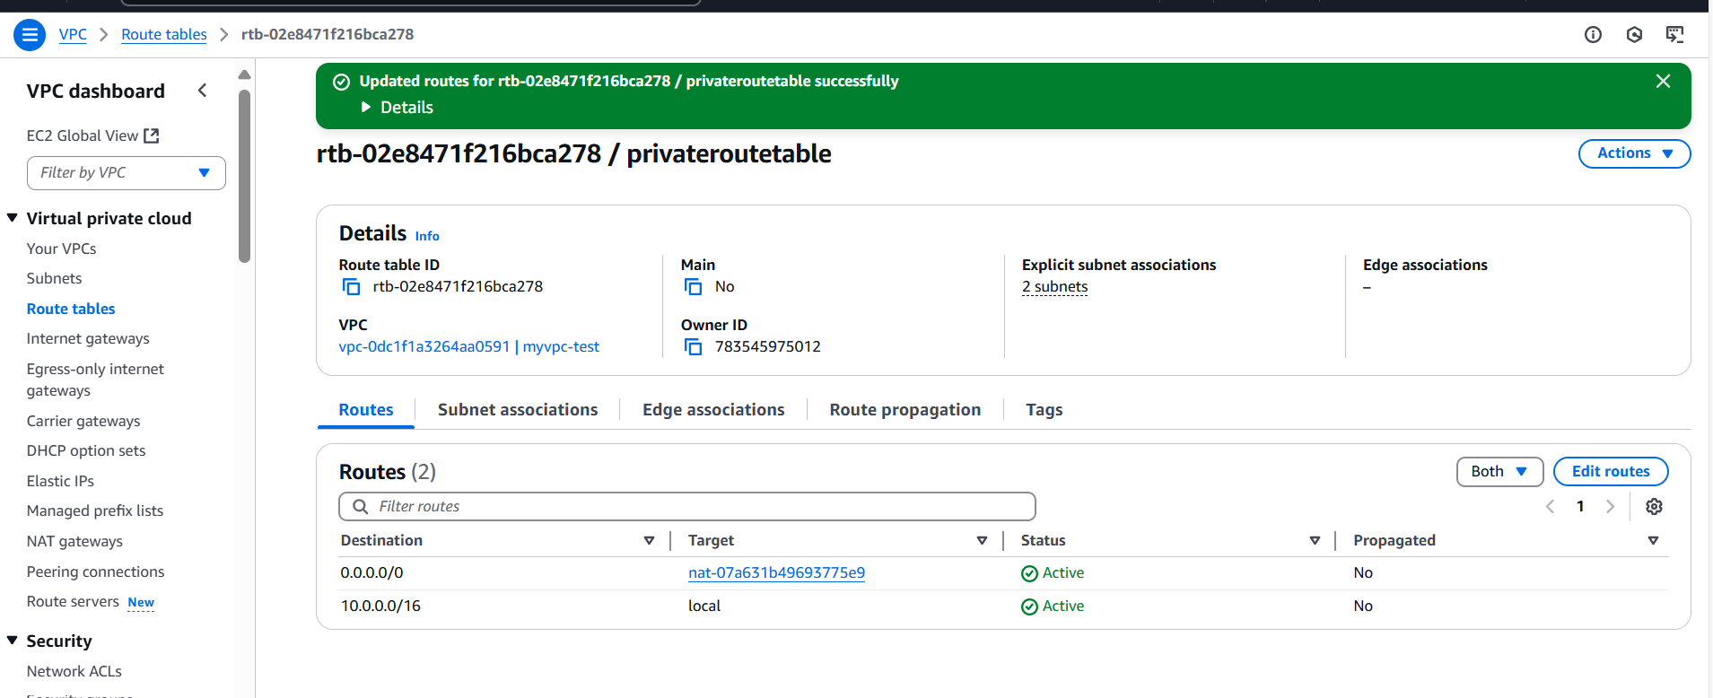

Test Connectivity

- Launch an EC2 instance in the private subnet.

- SSH into a public instance (if needed).

- Try accessing the internet from the private instance (ping google.com).

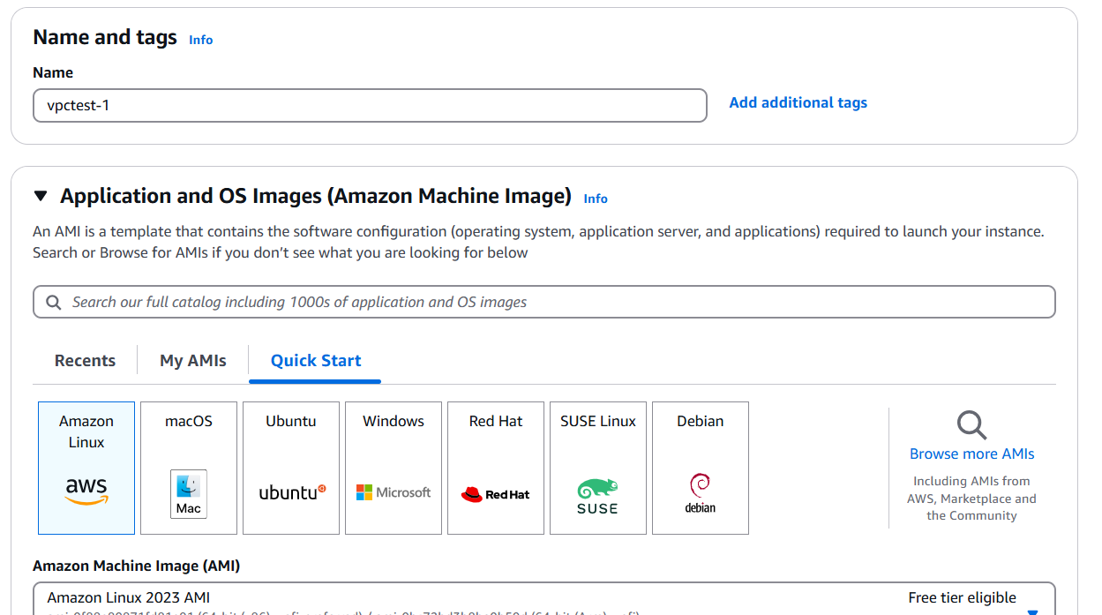

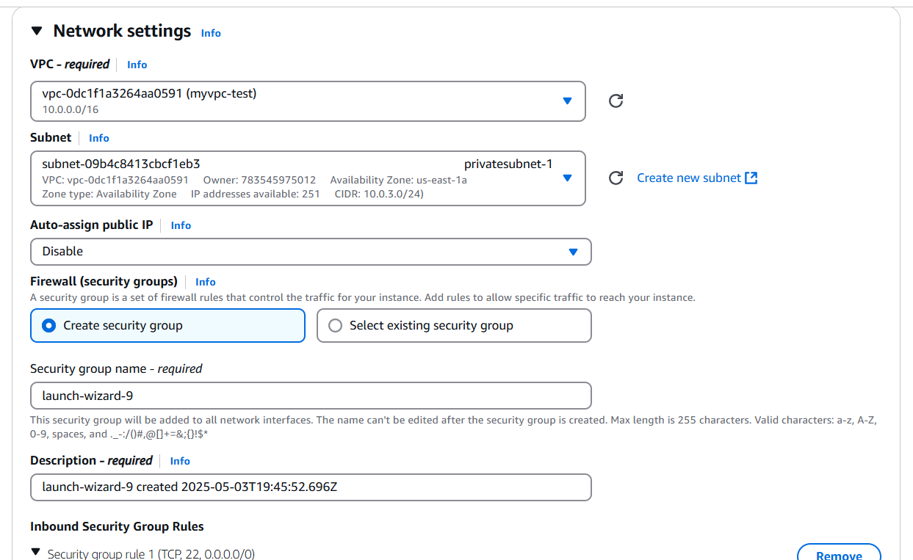

**9) Install Apache Tomcat in private ec2 and deploy a sample app.**

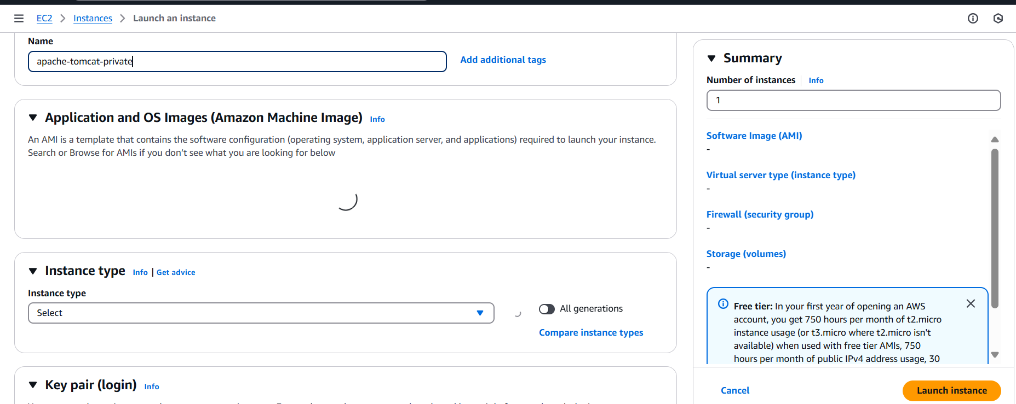

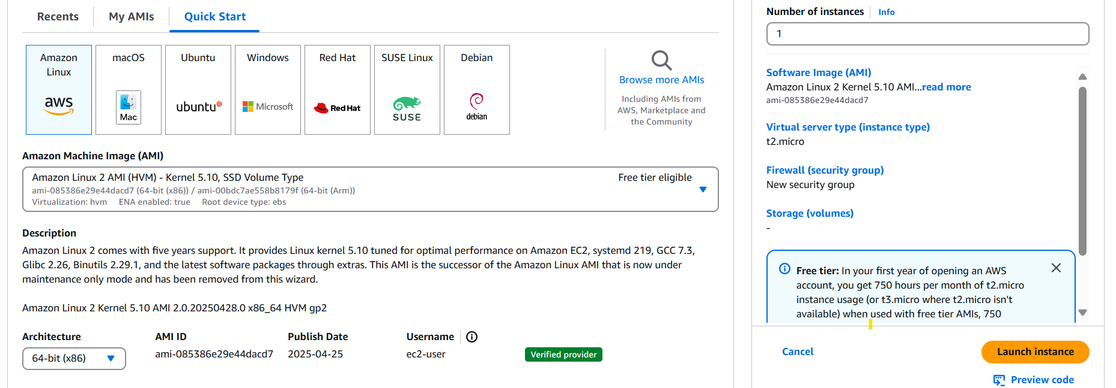

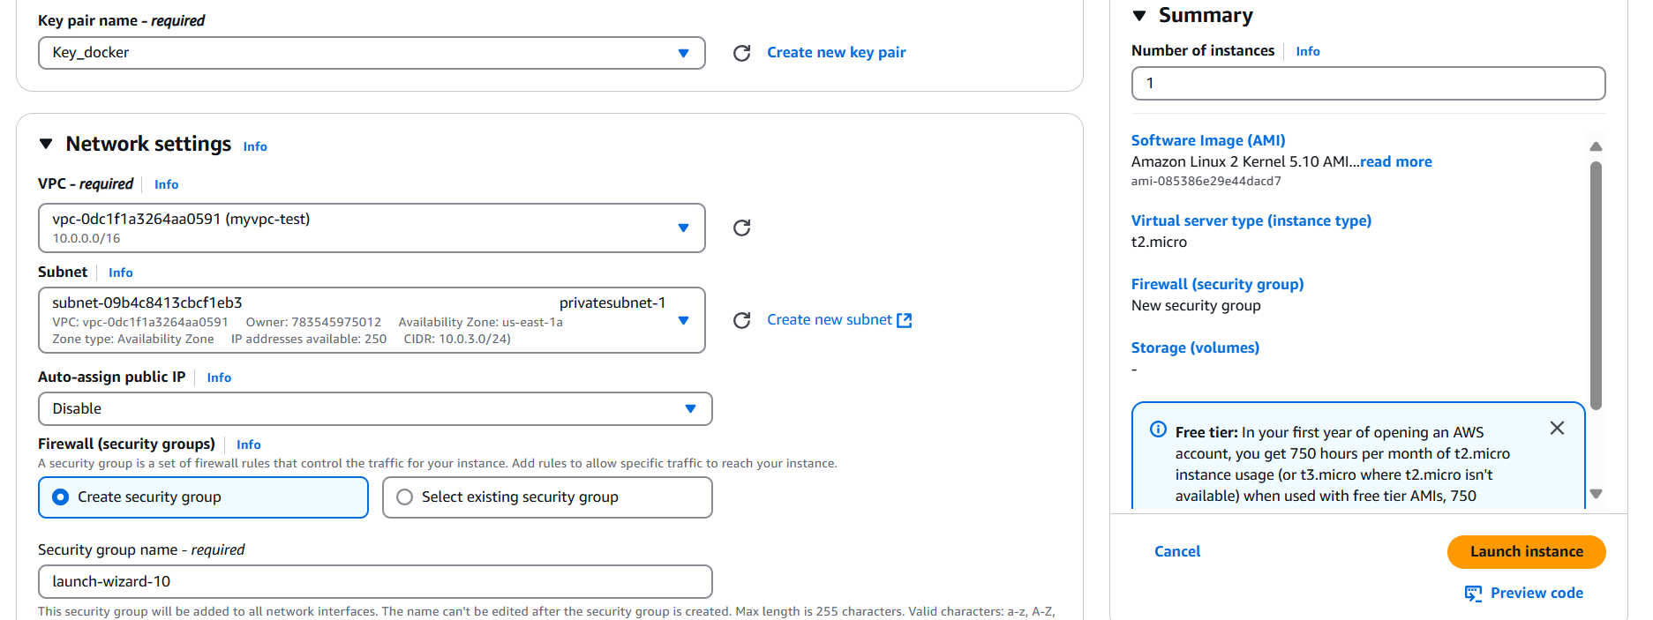

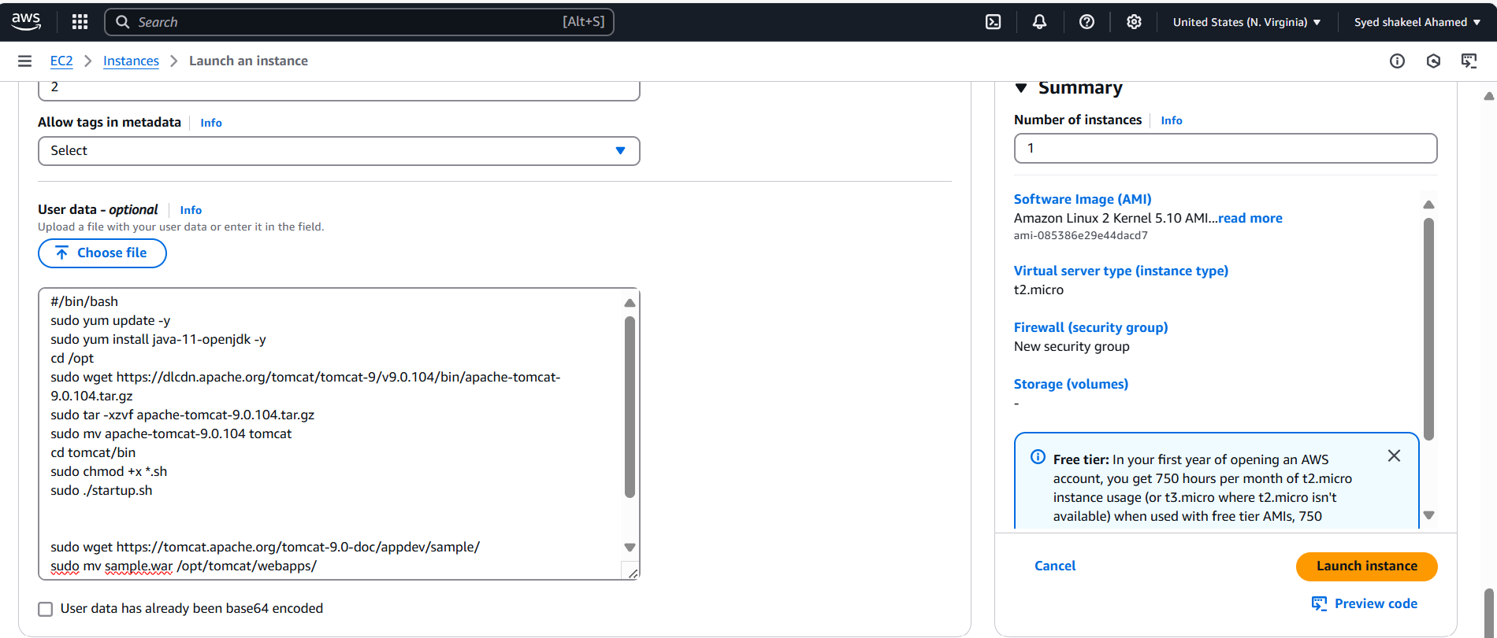

**10) Configure VPC flow logs and store the logs in s3 and cloudwatch.**

Traffic which is flowing to vpc will capture by VPC flow logs

Create VPC Flow Logs

- Open AWS Console and navigate to EC2 > VPC.

- Select the VPC for which you want to enable flow logs.

- Click Actions > Create Flow Log.

Choose Log Destination

- Select the Log Destination:

- CloudWatch Logs (for real-time monitoring)

- Amazon S3 (for long-term storage)

If storing logs in CloudWatch:

- Choose CloudWatch Logs as the destination.

- Click "Create new log group" or use an existing one.

- Assign an IAM role that allows VPC flow logs to write to CloudWatch.

- Click Create Flow Log.

If storing logs in S3:

- Choose Amazon S3 as the destination.

- Select an existing S3 bucket or create a new one.

- Set up proper IAM permissions for flow logs to write to S3.

- Click Create Flow Log.

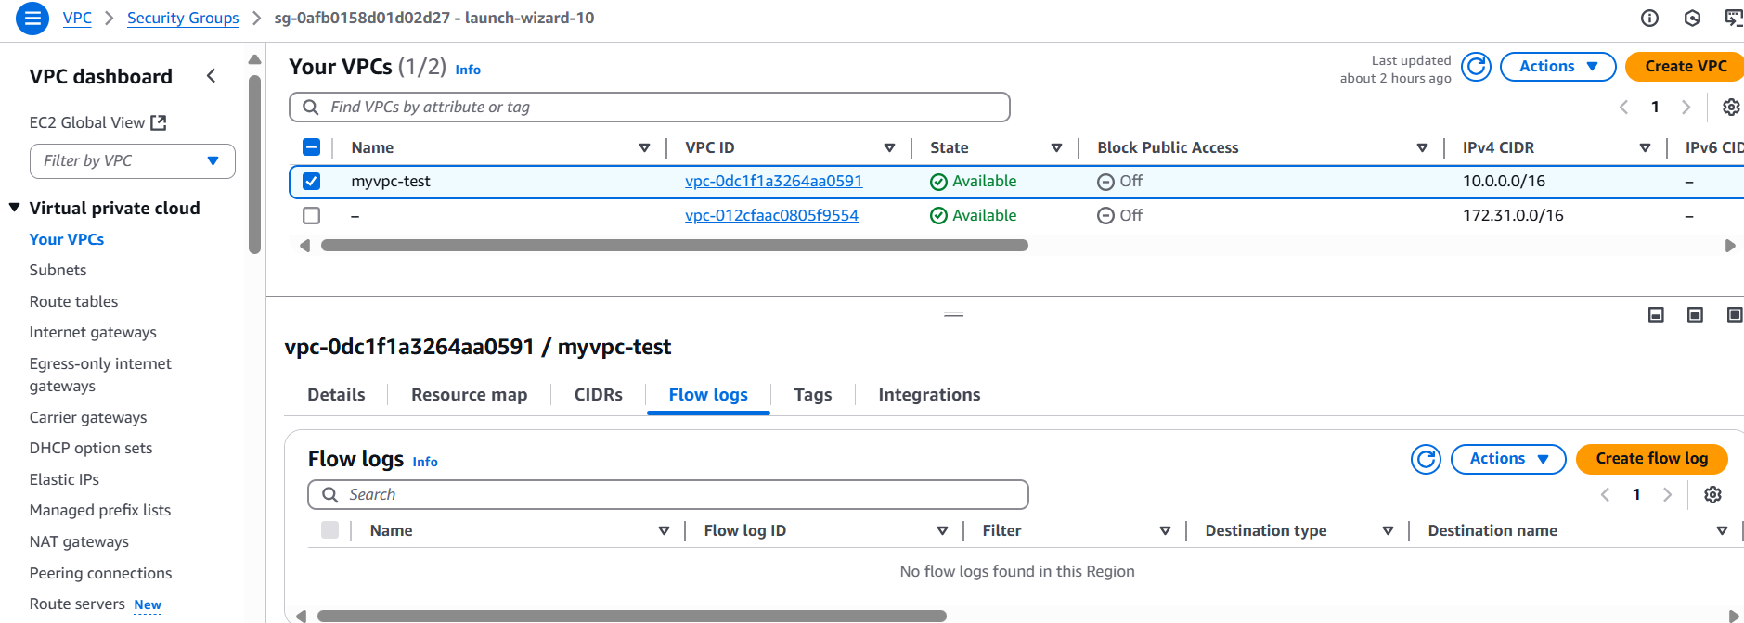

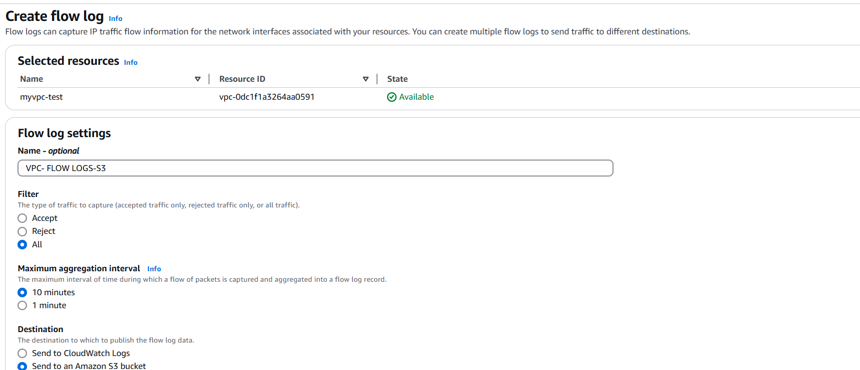

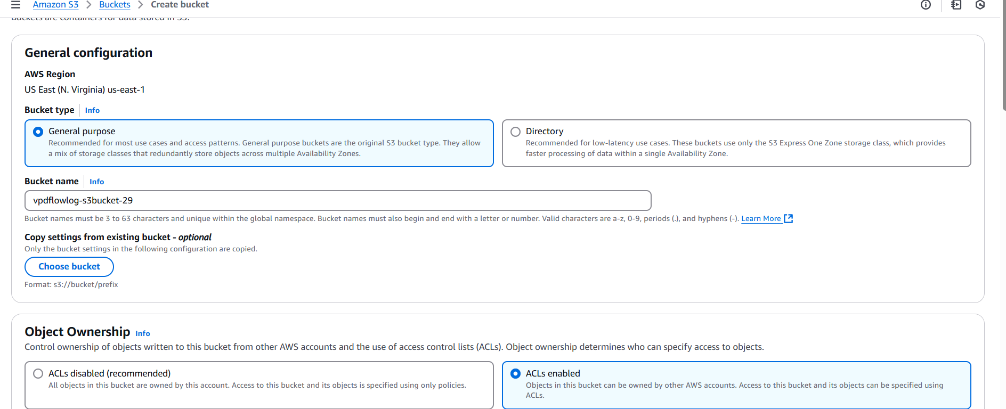

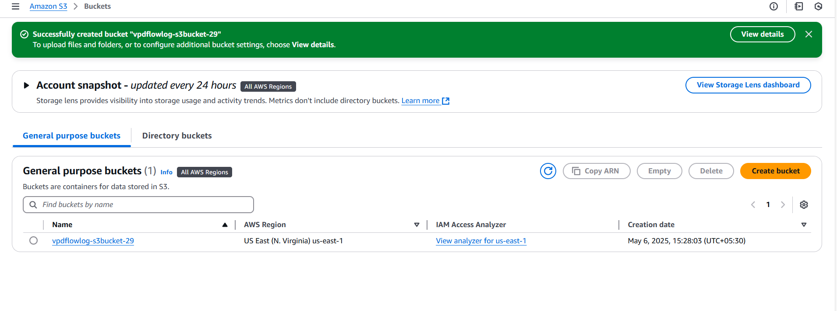

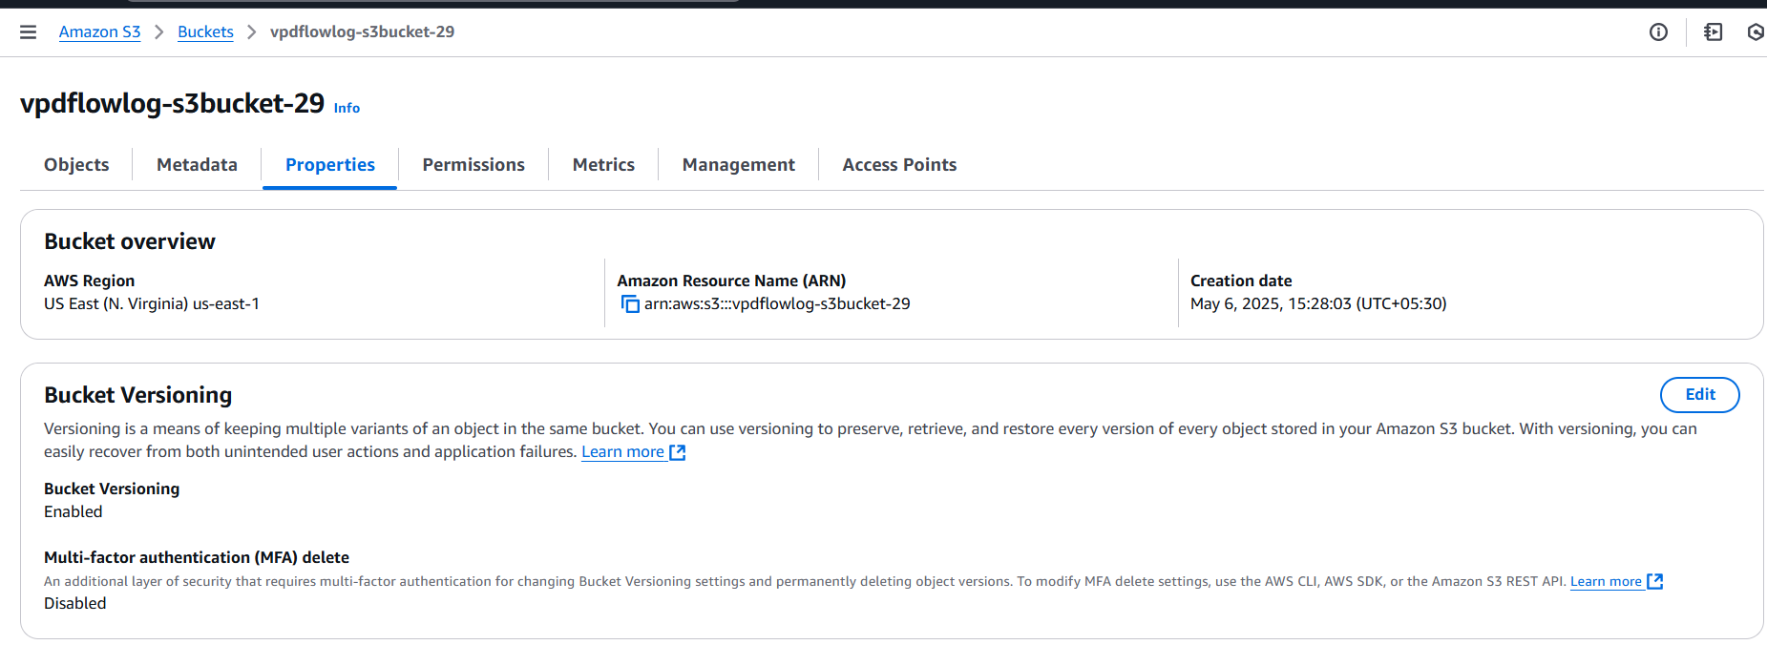

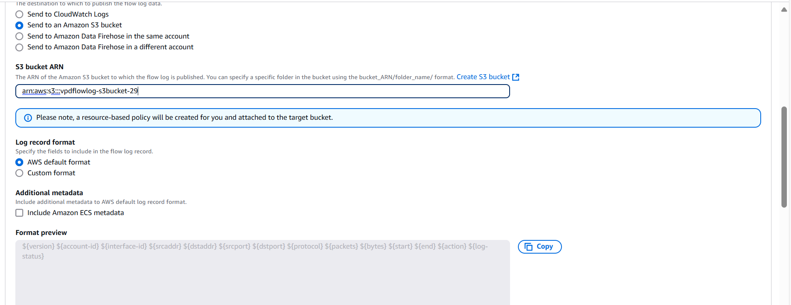

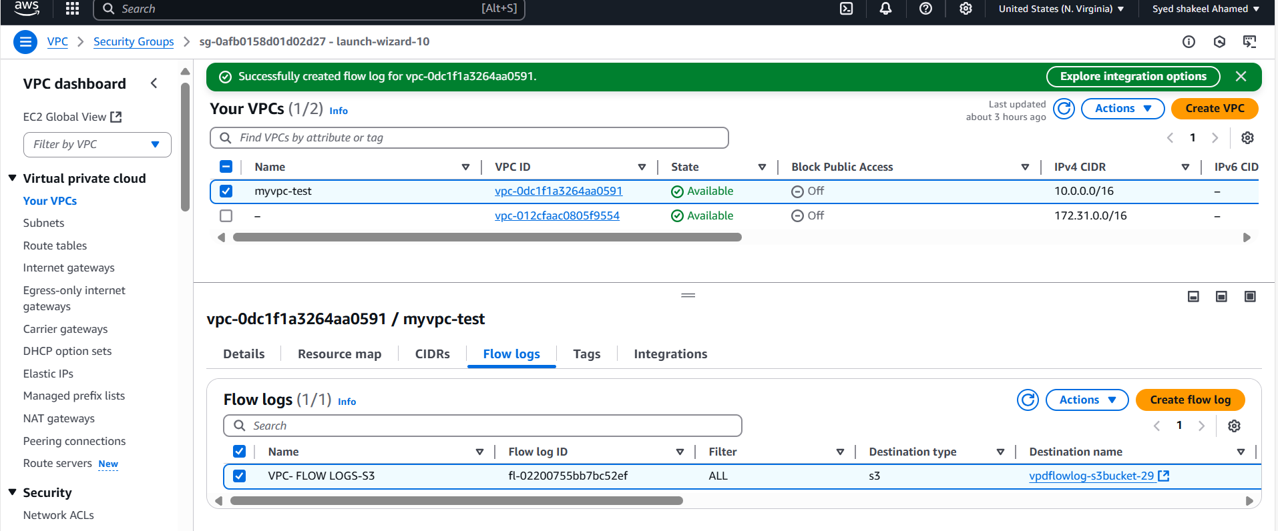

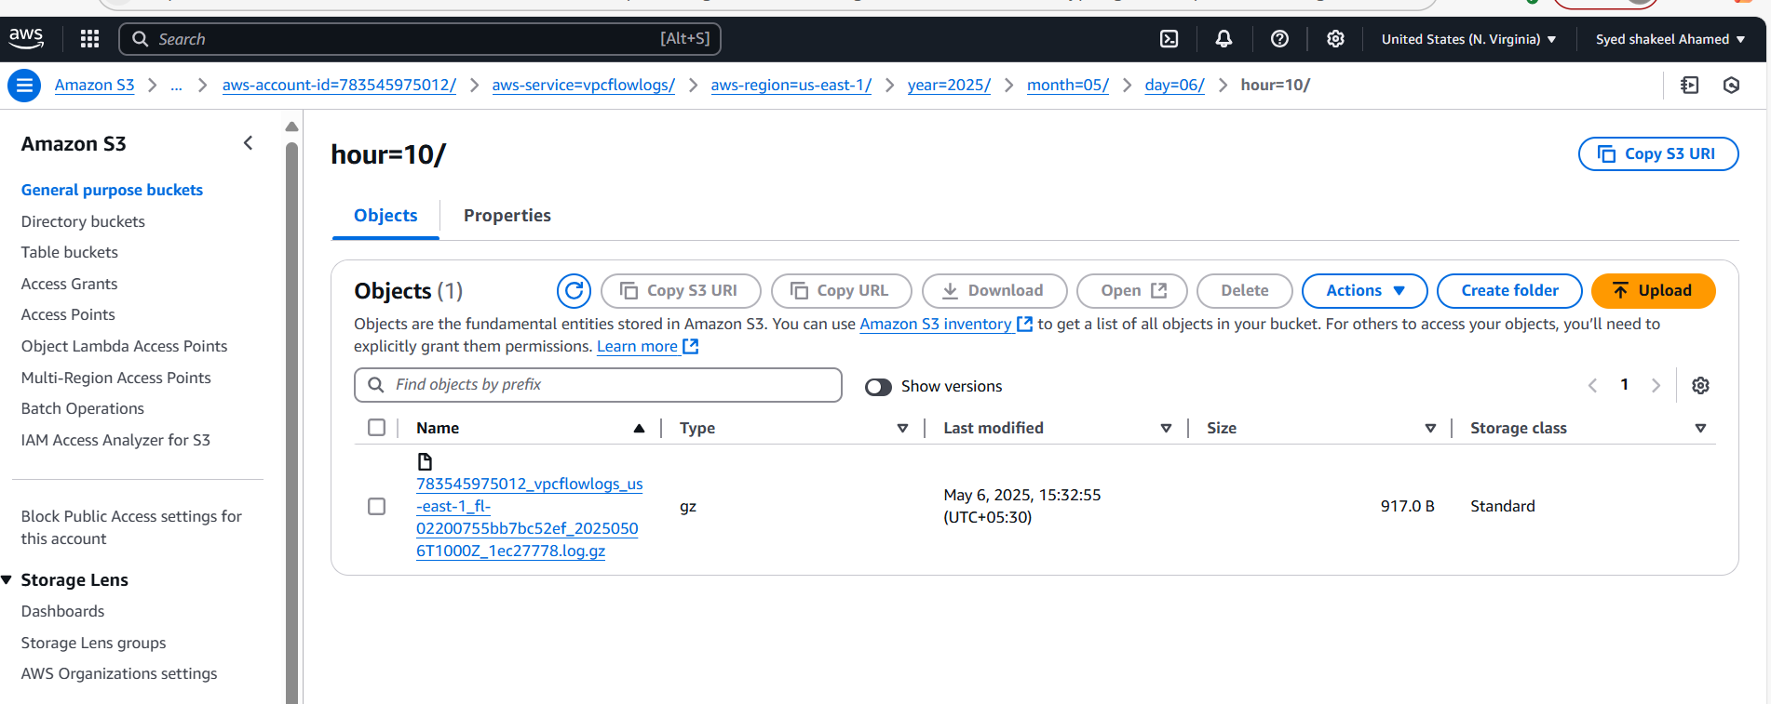

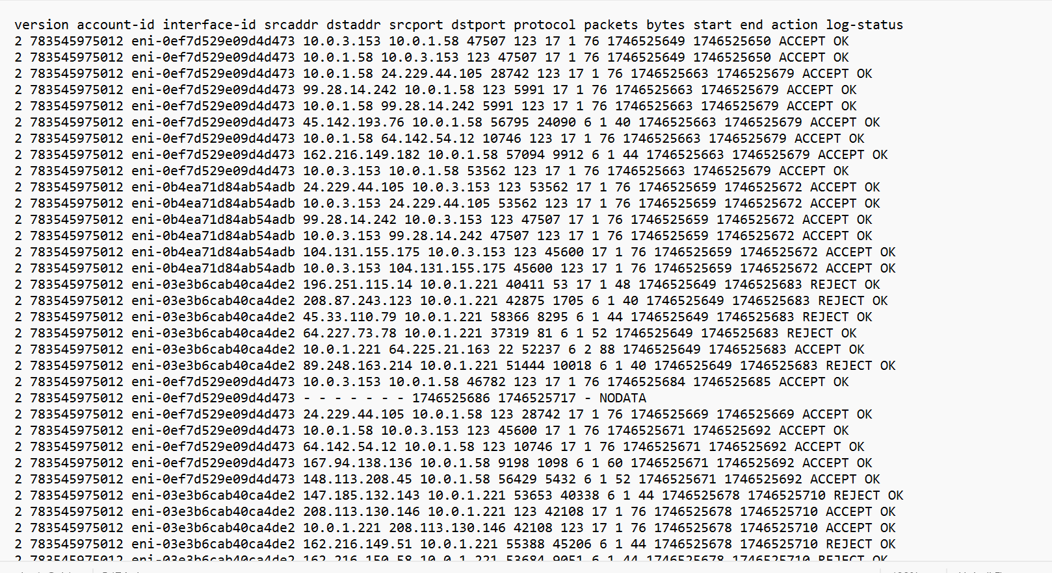

Cloudwatch:

